Swarm Robotics and its Applications

Anonymous Student
School of Science and Computer Engineering
University of Houston-Clear Lake
2700 Bay Area Boulevard
Houston, Texas 77058

Abstract
Swarm robotics is the use a group of robots with relatively simple capabilities in a coordinated effort to achieve complex behaviors or goals [1,2]. The three characteristics by which swarms are evaluated are: robustness (the ability to continue functioning in some fashion in a degraded or abnormal state), flexibility (the ability to deal with new or changing requirements), and scalability (the ability to handle an increase or decrease in size) [2]. The goal of this paper is to give a brief background in the concepts of swarm robotics/swarm intelligence and to review a collection of works in the field including: biologically inspired sensor swarms, undersea sensors and sensor networks, and satellite swarms.

Introduction
Research in the field of Swarm Robotics centers on the study of the use of relatively simple robots which, through communication, work together to accomplish a more complex goal. It is “inspired by, but not limited to the emergent behavior observed in social insects” [1]. This emergent behavior or “swarm intelligence” can be leveraged to accomplish tasks in a variety of different, seeming unrelated fields. Taking their cues from Mother Nature, Joseph Fronczek and Nadipuram Prasad of New Mexico State University have proposed a “swarm of highly sensitive pressure sensors” in an effort to aid crewmembers of the International Space Station with quickly detecting and repairing pressure leaks [3]. Jules Jaffe and Curt Schurgers at the University of California, San Diego are working on the design of free-floating underwater sensors connected through a acoustic network in an effort to study coastal circulation patterns [4]. Finally, Owen Brown of the Defense Advanced Research Projects Agency and Paul Eremenko of Booz Allen Hamilton, in conjunction with various universities and private companies, are working on dividing spacecraft into a fractionated satellite swarm in an effort to leverage some the strengths of the swarm robotics concept [7]. As with most fields of study in Computer Science, swarm robotics can add value in a wide range of research areas.

Related Work
Bio-Inspired Sensor Swarms
Concepts
Joseph Fronczek and Nadipuram Prasad of New Mexico State University have identified the critical need for technologies for quickly locating and repairing pressure leaks in contained environments like the International Space Station. The location, isolation, and repair of atmospheric pressure leaks are one of the main emergencies on which the crew of the Space Station is regularly trained. If the crew fails to address the pressure leak in the allotted time, they are instructed to abandon the station via the escape module. Such leaks can stem from a couple of sources. Errors can occur during the operation of the ISS Environmental Control and Life Support System (ELCSS - a network of valves and piping used to create a vacuum environment within the ISS for the purposes of scientific experiments). In addition, impacts from space debris are a threat to the atmospheric integrity of the Station. While failures in the ECLSS are frequently due to a failed component that are easily identified and small in nature, leaks occurring due to debris impact are often unpredictable. By using robotic sensor swarms that can quickly locate and repair pressure leaks, critical time can be provided for the crews to make permanent repairs.
Given the task of locating pressure leaks, two questions must be answered: “Where is the source of depressurization in the system, and how extensive is the leak [3]?” Currently, the crew must search the entire Space Station environment, a time consuming prospect at best. Sudden pressure leaks tend to cause disturbances in the regular airflow patterns inside the Station. Consequently, if this shift in airflow patterns can be detected quickly, all on-board air circulation systems can be secured and the new patterns caused by the leak can be isolated.
Researchers often turn to the natural world for inspiration for solving problems by novel methods. The common cockroach uses a small appendage covered with thousands of tiny hairs to detect disturbances in the surrounding air alerting it to possible threats. The cockroach instinctively runs in the direction of the wind source [3]. This behavior is referred to as “a positive taxis” (directed movement towards a stimulus). Additionally, when the hive is threatened, bees have the ability to gather and exert defensive measures against the disturbing element [3]. Through communication, the bees contribute to the collective intelligence and enable fast response to the threat. Studies show that bees and other insects can locate food sources by sensing the odor of the food and use airflows to navigate toward the source. By mimicking these natural systems, a swarm of bee-like sensors that can detect disturbances in the surrounding atmosphere can be deployed in a loss of pressure event to locate the leak source, converge on that source, and affect repairs.
Experiments and Future Work
The first set of experiments proposed by the authors is a proof-of-concept using an enclosure containing a set of golf gall sized Styrofoam objects which is released when a pressure change is detected. A single leak scenario will be used for initial calibration, followed by a series of tests using various multi-leak and obstruction scenarios.
Eventually, a set of experiments in a microgravity environment such as the Space Station will be conducted. For these tests, a sensor swarm will be contained in a sensor used to detect a critical cabin pressure change [3]. When a change is detected, the swarm is released in the direction of airflow. This is determined using technology similar to what is used in smoke detectors. Each sensor will be spherically shaped and will either have an external surface that can mold to the shape of a detected leak or contain some substance which can be released when it is near the leak point [3]. Sensor location will be achieved using RFID tags and will need to contain a simple, relatively week propulsion system.
Swarm Characteristics
The one characteristic this concept does address is Scalability. As the number of swarm sensors increases, the ability for the swarm to locate and temporarily stop the pressure leak increases until some saturation point. Flexibility seems to be covered to some extent in the proposed experiments that included multiple leaks and/or various obstructions. However, the authors did not seem to address robustness. In fact, the proposed system has at a minimum a susceptibility to failure of the primary sensor’s ability to detect a change in cabin pressure. Inclusion of a manual release mode might allow crewmembers to still use the repair capabilities of the swarm once the leak is detected.

Undersea Sensor Networks
Concepts
Although the use of manned and unmanned systems in remote ocean exploration has yielded a “wealth of knowledge about heretofore-unknown oceanic processes” [4], the authors have identified a lack of technologies to “observe organisms and processes without disturbing them as they move with the natural motion of the oceans” [4]. They propose this can be accomplished through the development of an autonomous, free-floating underwater device that can collaborate or interact with other such devices through an acoustic underwater network. [4,5]. They hope this will provide insights into “the interactions between ocean currents and underwater ecosystems and our impact on them” [4]. Current ocean sensing technologies use sensors that are either stationary or guided. However, the “natural dynamics such as waves, tides, and currents play a major part in oceanic interactions” [4]. Truly complete observation of these interactions cannot be achieved with sensors that are not subject to those dynamics.
Networked swarms of the proposed free-floating sensors could create three-dimensional maps coastal circulation. These maps could give researchers better understanding of various phenomena such as the spread of pollutants and the evolution of planktonic communities.
Experiments and Future work
The first step taken towards realizing this concept was the development of “ a single actively ballasted prototype drogue equipped with a temperature and pressure sensor” [4]. This sensor and associated ballasting system allows the drogue to either “maintain a depth, ride an isotherm, or vertically migrate” [4]. A picture of the prototype drogue can be seen below:

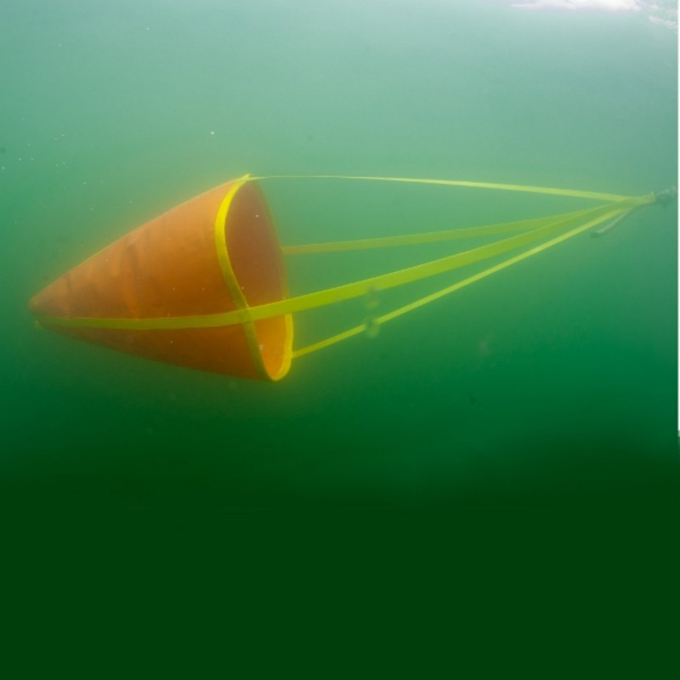

The drogue underwent various sea trials in order to evaluate its ability to maintain a fixed depth, temperature, or salinity both in a 10m tank and in the open ocean approximately 2 miles offshore. Additionally, tests where conducted to test “the potential of both tracking and communicating with the vehicle acoustically” [4]. These tests showed that the effective range (.5 km – 2 km) of communication was dependant on the temperature structure of the water. However, oceanographers have interests in studying oceanic processes with ranges of 5 km – 10 km. Therefore, the authors are pursuing the “idea of networking drogues so that information can be passed from a ship or shore station to them and retrieved from them” [4].
The authors’ vision for future development includes real-time data extraction from drogues. This would enable the ability to “guide the deployment of additional resources (more elaborate sensors, guided vehicles, or research vessels) and give a user the ability to relay commands to the swarm of drogues (essential for supporting cooperative tasks like coordinated depth control and sampling strategies, and enable location estimation and tracking [4]”. Due to limitations of current communication technologies, there is the need to create a “multi-hop, ad-hoc acoustic network to interconnect the drogues” [4]. Vessels and buoys would link to this drogue network and “relay data to land based users and laboratories” [4]. Most work in underwater acoustic networking has used stationary sensors and self-propelled elements [5,6]. Since this concept must include passive sensors subject to the ocean’s currents and have a limited energy supply [4], the supporting acoustic network must “incorporate adaptive mechanisms to deal with the uncontrollable drogue mobility behavior” [4].
Swarm Characteristics
A key component to a successful robotic swarm is communication. Without that element, none of the individuals will be able to work together and the opportunity for swarm intelligence to emerge is lost. When further progress is made on the development of the acoustic network technology, this concept can grow to further address the issues of flexibility, robustness, and scalability.

Satellite Swarms
Concept
Owen Brown of Defense Advanced Research Projects Agency (DARPA) and Paul Eremenko of Booz Allen Hamilton have put forth a vision for what they term “responsive space”. They define this as “the speed with which a space system can be made to react to various forms of uncertainty, ranging from geopolitical operational requirements to technical failures to fluctuations in the acquisition funding stream” or more simply, “ the capability of space systems to respond rapidly to uncertainty [8]. As the authors’ view is that large, monolithic spacecraft are “notoriously unresponsive”, they are proposing the adoption of a fractionated architecture where a satellite is “decomposed into a set of similar or dissimilar” components linked wirelessly while in cluster orbits [8]. These homogenous or heterogeneous satellite swarms would work together to provide equivalent or, in most cases, expanded capabilities. DARPA’s demonstrator system for this architecture is called F6 (Future, Fast, Flexible, Free-Flying, Fractionated Spacecraft united by Information eXchange) [8].
The reason for proposing this architecture is to produce a system that can mitigate, to a certain degree, the uncertainty that is present “throughout the lifecycle of a space system” [8]. In the authors’ view, this uncertainty can be decomposed into six sub-categories. Technical uncertainty involves risks from systems internal to the spacecraft). Environmental uncertainty is due to transients beyond the normally expected range of environmental conditions [8]. Launch uncertainty stems from risks associated with the spacecraft reaching orbit. Demand uncertainty due to changes in the need for services or capabilities provided by the spacecraft. Requirements uncertainty involves risks related to uncertainty in requirements from the design phase and is caused by the interaction of unrelated requirements on separate systems on the spacecraft. Funding Stream uncertainty stems from risk due to competing programs and expense prioritization [8].
The solution put forth in this paper involves the use of “free-flying modules in cluster orbits” sharing power and data through a wireless network. This creates a “virtual satellite’ [8]. This would enable a swarm of satellites where a failed (or improved) component can be replaced without the need for complex rendezvous or docking. Imagine augmenting processor resources, power generation, or payload capabilities on the fly on a temporary or permanent basis simply by adding modules to the swarm. A satellite swarm could disperse to avoid other satellites or enemy munitions.
This fractionated architecture addresses each of the categories of uncertainty. Technical uncertainty is reducing by minimizing risk due to failed or outdated components with its ease of module replacement. Environmental risks due to space junk or other objects can be avoided by dispersing the swarm. Launch uncertainty is addressed by allowing modules to be placed into orbit by separate launch sources. Payload and swarm composition flexibility mitigate risks due to Demand and Requirements uncertainty. Finally, funding uncertainty is reduced using incremental development of the satellite swarm.
Experiments and Future work
In February 2008, DARPA awarded contracts to:
Contracts are being awarded to the following groups:
- The Boeing Co., Huntington Beach, Calif., teamed with L3 Communications, Millennium Space Systems, Octant Technologies, and Science Applications International Corp.
- Lockheed Martin Space Systems Co., Palo Alto, Calif., teamed with Aurora Flight Sciences, Colbaugh & Heinsheimer Consulting, Vanderbilt University, and Lockheed Martin Integrated and Global Systems
- Northrop Grumman Space & Mission Systems Corp., Redondo Beach, Calif., teamed with Alliant Tech Systems Inc., Aurora Flight Sciences, Juniper Networks, L3 Communications, BAE Systems, Cornell University, Jet Propulsion Laboratory, Massachusetts Institute of Technology, University of Southern California, and University of Virginia
- Orbital Sciences Corp., Dulles, Va., teamed with IBM, Jet Propulsion Laboratory, Georgia Institute of Technology, SpaceDev, and Aurora Flight Sciences
Each contractor was tasked with:
During the first phase, contractors will:
- Develop key technologies to enable the fractionated approach, including robust networking, reliable wireless communications, fault-tolerant distributed computing, wireless power transfer, and autonomous cluster navigation
- Select a space system mission of value to a national security space stakeholder and develop a system design to accomplish that mission
- Develop an innovative analytical approach using econometric tools that determine the risk-adjusted cost and value of a both a fractionated space system and a monolithic program of record with equivalent capability; and
- Develop an evolved hardware-in-the-loop test-bed to emulate the designed fractionated spacecraft using a cluster of networked computers.
Swarm Characteristics
This idea of a fractionated satellite swarm possesses all the characteristics of swarm robotics. The authors by design are leveraging the strengths of swarm robotic architectures to address current satellite design issues in the areas flexibility, robustness, and scalability. However, many may not consider this to be a true robotic swarm since the “intelligence’ or complex behavior of the swarm does not emerge from the simpler interactions of the modules, but is instead the result of one or more “leader” module(s) or human operator’s. Although, further development in the modules’ ability to self organize and redeploy could address this “deficiency”.

Conclusion
Scientists and Engineers throughout history have turned to Nature for inspiration and ideas for problem solving. Observing the behavior of groups of bees or ants working together has in part given rise to the field of Swarm Robotics. The power of that concept can be applied in a variety of areas ranging from the study of coastal circulation in the ocean to the creation of a more reactive and survivable satellite design.

References

[1] Swarm Robotics
http://www.en.wikipedia.org/wiki/Swarm_Robotics

[2] A Review of Studies in Swarm Robotics, L. Bayindir and E. Sahin, Turkish Journal of Electrical Engineering & Computer Sciences, VOL. 15, NO.2 2007

[3] Bio-Inspired Sensor Swarms to Detect Leaks in Pressurized Systems, Fronczek, J.W.; Prasad, N.R., Man and Cybernetics, 2005 IEEE International Conference on Volume 2, 10-12 Oct. 2005 Page(s): 1967 - 1972 Vol. 2 Digital Object Identifier 10.1109/ICSMC.2005.1571435

[4] Sensor Networks of Freely Drifting Autonomous Underwater Explorers, J. Jaffe, C. Schurgers, WUWNet '06: Proceedings of the 1st ACM international workshop on Underwater Networks September 2006 Publisher: ACM

[5] Distributed Surveillance Sensor Network (DSSN), http://www.nosc.mil/robots/undersea/dssn/dssn.html
SPAWAR Systems Center, San Diego, June 2006.

[6] A Survey of Practical Issues in Underwater Networks, J. Partan, J. Kurose, B. N. Levine, ACM SIGMOBILE Mobile Computing and Communications Review, Volume 11 Issue 4 October 2007 Publisher: ACM

[7] Fractionated Space Architectures: A Vision for Responsive Space, O. Brown, P. Eremenko, and B. A. Hamilton, 4th Responsive Space Conference April 24-27, 2006 Los Angeles, CA

