Programming Assignment 4
The purpose of this program is to manipulate an array with menu options. The program will print a menu, and execute the selected functions until you choose to exit the program.
For this program, you will use one array. In your main function, define a constant MAXSIZE for an array and set the MAXSIZE to 30. This would be the maximum size of the array. However, the user gets to input the size of the array that they want to use.
The main() function will always ask the user to input the size of the array first, and then it will call the initialize function, which will initialize the values in the array as instructed in the transformation description below. After this, it will then enter a while loop presenting a menu of options as illustrated below.
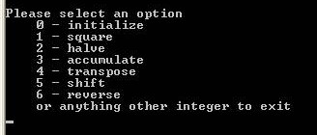
The program will continue to prompt the user for an action until the user chooses to exit.
The transformations are described below with the function prototypes given. For all of the functions, the first argument is the array (which is passed by reference). The second argument is the size of the array.
- void initialize(int a[], int size) - Initialize the array to contain the values from 0 to size - 1, in array positions 0 to size – 1.
Eg:
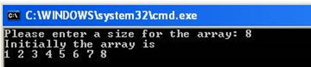
- void square(int a[], int size) - Square every value in the array, as illustrated below.

- void halve(int a[], int size) - Halve every value in the array (rounding down), as illustrated below.
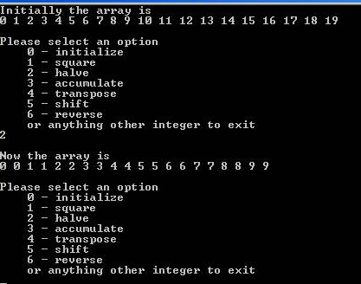
- void accumulate(int a[], int size) - For every array index N, set the value at array index N to be the sum of the values from array indexes 0 through N, as illustrated below. For instance, a[3] should be set to a[0] + a[1] + a[2] + a[3].
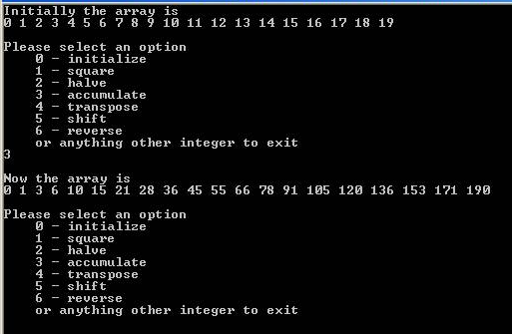
- void transpose(int a[], int size) - For every pair of neighbors in the array, switch their values. That is, switch the value of a[0] with that of a[1], and a[2] with a[3], etc., as illustrated below.
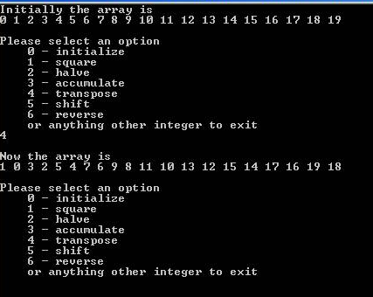
- void shift(int a[], int size) - Move every value in the array to the next index position, e.g., the value of a[3] is moved to a[4]. Move the value of the last index to the first index, e.g., a[19] is moved to a[0] for an array of size 20. The transformation is illustrated below.
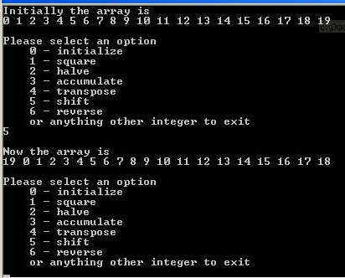

- void reverse(int a[], int size) - Reverse the values in the array, e.g., in an array of size 20 switch a[0] with a[19], a[1] with a[18], etc., as illustrated below.
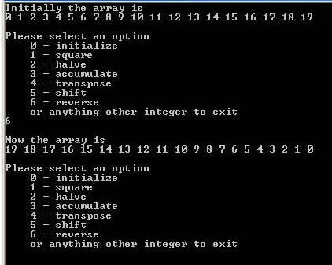

Important:
- The menu should keep displaying until the user chooses to exit.
- Use the initialize function to first initialize the array.
- Each transformation must be implemented in a function with the prototype as given above.
- Ensure that your functions stay within the array (do not do "out-of-bounds" array manipulations).
Students should hand in a flow chart or pseudocode of the program and a printout of the source code (make sure it is documented properly according to the UHCL guidelines). Please make sure that all this is in an envelope or folder. Students should also upload a soft copy of your program as before too.

