FILES ON FAT

Download the image file from here (<http://sceweb.sce.uhcl.edu/abeysekera/itec3831/Assignments/FAT32_image.dd> ).

Open the image with FTK Imager and answer the following questions.

Part 1:

|  |  |  |  |
| --- | --- | --- | --- |
| 1. How many sectors are in a cluster |  | 3. How many FATS |  |
| 2. How many bytes are in a sector |  | 4. The starting cluster of the “ROOT Directory” |  |

Part2: Show the starting sector (**physical sector #**) for each of the following sections in the image:

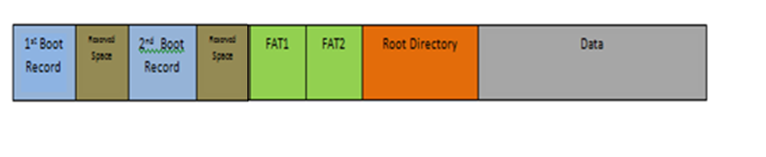

Part 3: List all files (include deleted files – file names that begin with an **E5** means that it is deleted)

|  |  |  |  |  |  |  |
| --- | --- | --- | --- | --- | --- | --- |
|  | File Name | Size (bytes) | File Attribute Values | Starting cluster | Total cluster | The list of clusters |
| Example | pam.txt (deleted) | 10,669 bytes | 0x 20 | 0x 00 03 | 21 | 0x 03-> Unknown  File was deleted, the next cluster is unknown. |
| File 1 |  |  |  |  |  |  |
| File 2 |  |  |  |  |  |  |
| File 3 |  |  |  |  |  |  |
| File 4 |  |  |  |  |  |  |
| File 5 |  |  |  |  |  |  |
| File 6 |  |  |  |  |  |  |
| File 7 |  |  |  |  |  |  |
| File 8 |  |  |  |  |  |  |