OCO: An Efficient Method for Tracking Objects in Wireless Sensor Networks

T. Andrew Yang | Sam Phu Manh Tran | Duy Cao | Tuan Anh Nguyen
University of Houston – Clear Lake
2700 Bay Area Blvd., Houston, Texas, 77058, US
yang@UHCL.edu

Corresponding author:
T. Andrew Yang, email: yang@UHCL.edu, phone: 1-281-283-3835, fax: 1-281-283-3870

ABSTRACT

Sensor nodes in a wireless sensor networks (WSN) are constrained in energy supply, performance, and bandwidth. Besides, a WSN may be deployed in a hostile environment, leading to lack of physical security. Designing a WSN for tracking objects, we have identified five requirements: (i) accuracy, (ii) energy efficiency, (iii) optimized computation, (iv) re-configurability, and (v) secure communications. The goal is to maximize the WSN’s lifetime while ensuring accuracy of target tracking and secure operation of the WSN. Existing methods, such as the LEACH-based algorithms, either suffer redundancy in data and sensor node deployment, or require complex computation. There exists a demand for self-organizing and routing capabilities in the WSN.
To meet that demand, we have devised OCO (Optimized Communication and Organization), which is an efficient method that builds and maintains a WSN with self-organizing and routing capabilities. OCO includes 4 phases: position collection, processing, tracking, and maintenance. In the position collection phase, the base-station collects positions of all reachable nodes in the network. In the processing phase, it applies image processing techniques to clean up the redundant nodes, detect border nodes, find the shortest path from each node to the base, and assign various roles to the nodes. Depending on the density of the nodes deployed in the sensing area, the process of cleaning up redundant nodes results in a certain percentage of the nodes being included in the network; the others (the redundant nodes) become inactive to conserve energy. In one of our simulation runs, for example, the initially deployed 1,000 nodes were reduced, after the process of cleaning up redundant nodes, to less than 300 nodes, eliminating data and sensor node deployment redundancy, while the 700 or so redundant nodes enter the SLEEP mode to save energy, and may be awakened later (during maintenance phase) to replace dying or dead nodes. In the tracking phase, the sensors in the network all work together to detect and track intruding objects. The maintenance phase involves re-organizing the network when, for example, a change in the topology of the network occurs, or some of the sensor nodes become dead. Based on simulation-based evaluation of OCO against two other methods, LEACH and Direct Communication (DC), OCO exhibits superior accuracy with excellent energy efficiency. OCO appears to have met the first four requirements listed above.
Following the introduction and a survey of related work, we present the OCO method, including its algorithms and message structure. Several special messages have been devised to handle various tasks in the maintenance phase of the method (for example, to address issues such as dead nodes in the WSN). The second half of the paper focuses on the simulation-based evaluations of OCO against LEACH and DC. The evaluations were performed under various scenarios (with no intruder object, with one intruder object, and with multiple intruder objects, respectively). Four metrics were used when evaluating the selected methods: total energy consumption, accuracy of target tracking, cost per detected point, and time before the first dead node. The paper concludes with a summary and possible future extensions.

Keywords: Wireless Sensor Networks; OCO; Target Tracking; Simulation
OCO: An Efficient Method for Tracking Objects in Wireless Sensor Networks

- INTRODUCTION
Wireless sensor networks (WSN) have major impact upon military and civilian applications, including environment monitoring, target surveillance, industrial process observation, tactical systems, space and planetary explorations, etc. In these scenarios, target tracking is one of the most important tasks.
With its relatively small size, a sensor node is typically limited in its processing power, battery life, and radio communication strength. In addition, due to the environments where the WSN is typical deployed (sometimes inside a hostile area), physical security of the sensor nodes is usually not available. The sensor nodes may be damaged by natural forces (e.g., earthquake) or human attacks, and the communications among the sensor nodes or between a sensor node and the base station may be compromised. The successful design of a WSN depends on how well those challenges are addressed by the designer. When using a wireless sensor network for tracking moving objects, we have identified five critical requirements:
- Accuracy of target detection – The primary goal is to ensure consistent accuracy of target tracking without reducing the network’s longevity.
- Efficient energy dissipation – The basic goal of ensuring energy dissipation efficiency is to increase the overall longevity of the WSN.
- Optimized computation – Due to the limited battery power stored in a sensor node, computation performed in the sensor node must be optimized, in order to incur the minimum energy dissipation.
- Re-configurability – When one or more of the sensor nodes cease to function, the network should be able to self-organize or re-configure itself, in order to re-construct a functional WSN allowing the mission to be continued.
- Secure communications – In the context of WSN security, we focus our attention on the following security features: origin integrity, data integrity, confidentiality, and availability.
Existing methods such as the LEACH-based algorithms [4] suffer problems such as complex computations, redundant data, and redundant sensor deployment. Those drawbacks result in energy use inefficiency and/or expensive computation overhead, a violation of requirements b and c. To tackle these problems, we have devised a method called OCO (Optimized Communication and Organization), which is an efficient method that builds self-organizing and routing capabilities into a sensor network. OCO ensures maximum accuracy of target tracking, efficient energy dissipation, and low computation overhead. An OCO-based WSN is re-configurable in the sense that it can self-organize itself when some of the nodes cease to function. The OCO method therefore satisfies the first four of the above listed requirements.
Simulation-based evaluations were conducted to compare the performance of OCO against two other methods, LEACH and Direct Communication (DC) [3], under various scenarios (with no intruder object, with one intruder object, and with multiple intruder objects, respectively). Four metrics were used when evaluating the selected methods: total energy consumption, accuracy of target tracking, cost per detected point, and time before the first dead node. Based on the comprehensive evaluations, OCO appears to consume less energy, while achieving superior accuracy.
In addition to performance evaluation, we have formalized the message structure of OCO, and have defined several special messages to handle various emergency scenarios in the operations of the WSN, for example, when one or more nodes are dead or running out of energy.
In the rest of the paper, we first provide an overview of methods related to target tracking in the sensor network, followed by a detailed discussion of the OCO method, including the algorithms and the message structure. We then discuss the simulation models and environment that we have built to evaluate the methods. The evaluation results of some of the scenarios are then presented. The paper concludes with a summary and anticipated future work.

- RELATED WORK
According to a survey by Chuang [2], there exist three main approaches for target tracking in sensor networks: tree-based, cluster-based, and prediction-based.
  - Tree-Based Methods
Tree-based methods organize the network into a hierarchy tree. Alternatively, a sensor network may be represented as a graph, in which the sensor nodes are vertices and the edges are links among nodes that directly communicate with each other. Kung and Vlah [5] developed a method called STUN (or Scalable Tracking Using Networked Sensors). In STUN, each edge of the graph is assigned a cost, which is computed from the Euclidean distance between the two nodes. Construction of the tree is based on the costs. The leaf nodes are used for tracking and sending collected data to the base through intermediate nodes. The intermediate nodes store a detected object set, and send update information to the base when there is any change in the detected object set.
STUN, however, has some limitations. First, the tree in STUN is a logical tree and does not reflect the physical structure of the sensor network; hence, an edge may consist of multiple communication hops and a high communication cost may be incurred. Lin, Peng, and Tseng [6] upgraded STUN with data aggregation. They developed a method calls DAT (or Deviation-Avoidance Tree). In DAT, a Voronoi diagram is used to define the zone for each node and to build a hierarchy tree. Update information is sent to the base only when a node detects an object within its zone. Although DAT helps to decrease redundant messages, it adds more computation to the nodes. Moreover, using the Voronoi diagram to build the tree does not guarantee that the distance among hops is short enough for multi-hops communications.
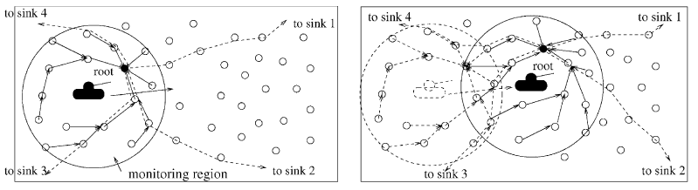
Figure 1: Using convoy tree to track a target and monitor its surrounding area
DCTC (Dynamic Convoy-Tree-based Collaboration) is a method by Zhang and Cao [14]. A DCTC network is divided into grids. Each grid elects a grid head. Nodes in the same grid can communicate directly. Normally only grid heads are awake. When a target first enters the detection region of the network, nodes that are awake and near the target can detect it. After that, these nodes construct an initial convoy tree by first selecting a node as the root of the tree. Then, the other nodes in the monitoring region of the root are added to the tree by selecting as its parent the neighbor that has the smallest distance to the root. Normally only nodes in the monitoring region are awake. Nodes out of the monitoring region are pruned. Since most nodes stay asleep to save power before the target arrives, the root should predict the object’s moving direction and activate the right group of sensor nodes, which then start monitoring their surrounding areas to detect the object. The process is illustrated in Figure 1 (redrawn from [14]).
DCTC, however, suffers some weaknesses. First, it tracks only one object at a time. Secondly, because only the grid heads are awake, the network may not detect an object near the border. Moreover, in DCTC, each node could be the root, so all nodes in DCTC must have sufficient qualifications to build the tree and predict the movement of the intruder. Finally, DCTC does not address the redundancy issue.
  - Cluster-Based Methods
Although being related to the tree-based methods, cluster-based methods use an algorithm called LEACH (Low-Energy Adaptive Clustering Hierarchy, originally developed by Heinzelman, etc. [4]), to build a hierarchy tree for the network. LEACH consists of 2 phases. In the set-up phase, sensors may elect randomly among themselves a local cluster head. By doing so, the network may balance energy dissipation across the whole network. The optimal number of cluster heads is 5% of the total number of nodes [4]. After the heads are selected, they advertise to all sensor nodes that they are the new cluster heads. Once the nodes receive the advertisements, each of them decides to which head it would belong. In the steady phase, sensors sense and transmit data to the base through their cluster heads. After a certain period of time spent in the steady phase, the network restarts the set-up phase again.
LEACH is more realistic than DC because it uses multi-hops to communicate. However, LEACH assumes all nodes have enough power to communicate directly with the base. Such an assumption is not true when the sensors spread across a large area. The cluster heads communicate directly with the base, possibly causing channel overload at the base station. Additionally, the cluster heads are randomly elected, so in some areas within the network there may not exist any cluster head.
  - Prediction-Based Methods
Prediction-based methods are built upon the tree-based and the cluster-based methods, with added prediction models. The models rely on heuristics based on some of following assumptions [2]:
- The moving objects will stay at the current speed and direction for the next few seconds.
- The object’s speed and direction for the next few seconds can be deduced from the average of the object’s movement history.
- Different weights can be assigned to the different stages based on the history.
PBS (Prediction Based Strategies) [13] and DPR (Dual Prediction-Based Reporting) [12] are examples of prediction-based methods. In general, the prediction-based approach produces efficient results. However, the weaknesses of the base algorithm (tree or cluster) still exist in this approach. Relying on the prediction models may also lead to unstable results. It may also incur heavy calculation. Finally, similar to other approaches discussed earlier, the prediction-based methods do not solve the redundancy problem.

- OCO: OPTIMIZED COMMUNICATION & ORGANIZATION
OCO includes 4 phases: position collection, processing, tracking, and maintenance.
- In the position collection phase, the base-station collects positions of all reachable nodes in the network.
- In the processing phase, it applies image processing techniques to clean up the redundant nodes, detect border nodes, find the shortest path from each node to the base, and then assign a specific role (redundant, border, forwarding) to each of the nodes in the network.
- In the tracking phase, the sensors in the network all work together to detect and track intruding objects.
- The maintenance phase involves re-organizing the network when, for example, a change in the topology of the network occurs, or some of the sensor nodes die (i.e., running out of power).

In the rest of this section, for each of the phases, we first define the message structure and then the operations and algorithms for that phase. The following discussions of the method are based on two assumptions: (i) First, it is assumed that each of the sensor nodes has a unique id. (ii) Each message sent has a unique message id, generated by a random number generator in the sending node.
  - Position collection phase
    - Message format definition
We define two message types for this phase, M1 and M2 (Table 1).

Table 1: Message types for the Position Collection phase
Purpose | Message type
- Message used to request the position of the sensor nodes | M1 = (message_id, source, destination, message_type), with message_type = 1  // In broadcasting mode: destination = ‘all’
- Message used to report the position of the sensor nodes to the base | M2 = (message_id, child, parent, message_type, (reporting_node_id, position)), with message_type = 2  // reporting_node_id = child, when the child node is reporting its own position;  // otherwise, the child node is forwarding the position of another node (one of its children or grand-children, etc.)

    - Operations
In the position collection phase (Table 2), the base collects positions of all reachable nodes in the network. When the sensor nodes are first deployed randomly in an area, the base starts by broadcasting a message of type M1 to its neighbors to gather their IDs and positions, and at the same time advertising its own ID as the parent ID of the neighbor nodes. Each of the base’s neighbor nodes, after sending its ID and position to the base by using a message of type M2, marks itself as recognized, and then performs the same actions as the base by collecting IDs and positions from their neighbors, and advertising itself as the parent node, and so on. Note that, when a node gets the position and ID from a neighbor, it forwards the information to its parent. This way the message will eventually reach the base.
Table 2: Algorithm 1 (the Position-Collection-Phase)
A. Set all nodes to be ‘unrecognized’.
B. Repeat until all nodes are ‘recognized’:
B.1. The base broadcasts a message to collect positions of all nodes (M1).
B.2. Each of the nodes, say n, that have received a M1 message must do the following:
- Node n needs to authenticate the M1 message. // not currently implemented yet
- If n is not ‘recognized’ yet, mark itself as ‘recognized’ and then perform steps c through e; else, skip the remaining steps.
- Record the sender as its parent (p). //Note: The child-parent relationship may be changed after the processing phase (because redundant nodes are removed).
- Send its own position to p (M2).
- Broadcast a M1 message to all its neighbors to collect their positions.
B.3. When a parent node receives a M2 message from one of its child nodes, it performs the following:
- It authenticates the message. // not currently implemented yet
- It forwards the reporting_node’s position to its own parent (M2).
Figure 2 shows a snapshot of the position collection phase during simulation. The red small circles are nodes already recognized by the base (the bigger circle). As shown in the diagrams, more nodes are recognized when the process continues (from left to right).
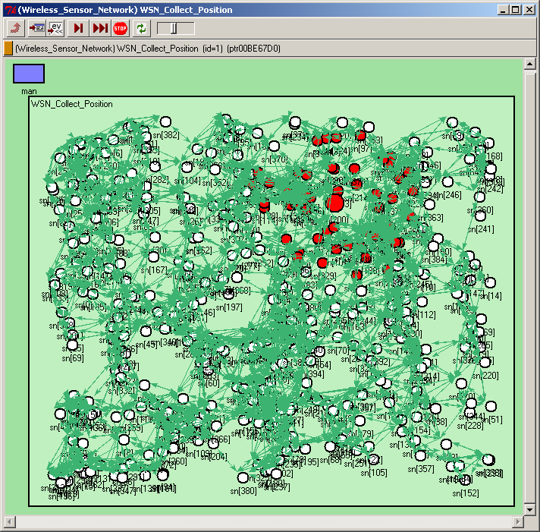 | → | 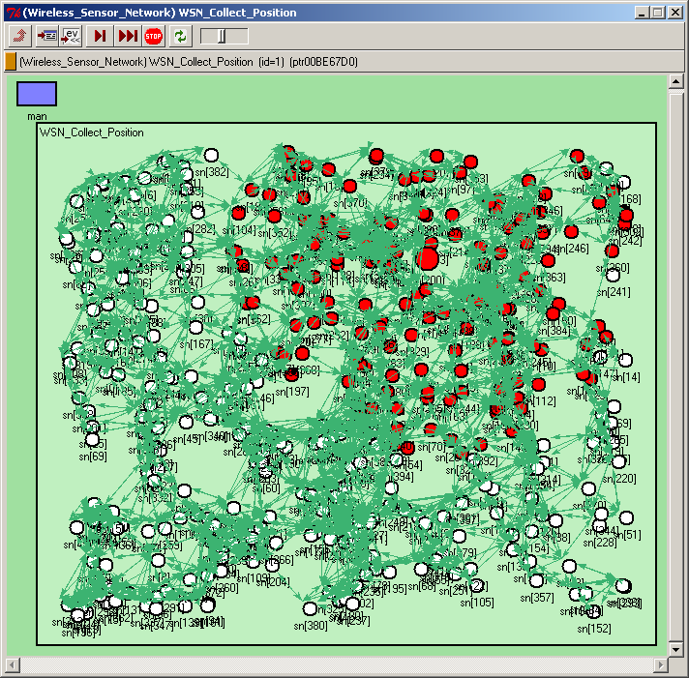
Figure 2: The position collection phase
  - Processing phase
In the processing phase, the base applies image processing techniques to clean up the redundant nodes, detect border nodes, find the shortest path from each node to the base, and assign a specific role to each of the sensor nodes. A node may be designated as a border node, a forwarding node, or a redundant node.
    - Message format definition
We define four message types for this phase, M3, M4, M5 and M6, all of which are sent at the end of the processing phase to assign specific roles to the sensor nodes. The first three steps of the processing phase involve computation in the base, so no messages are exchanged in those steps.
The format of the message types are in Table 8 (Subsection 3.2.2.4).
    - Operations
In the processing phase, it applies image processing techniques to clean up the redundant nodes, detect border nodes, and find the shortest path from each node to the base. The processing phase consists of three steps: (i) Clean up redundant nodes; (ii) Define the border nodes; (iii) Find the shortest path from each node to the base; (iv) Assign roles to the sensor nodes.
      - Clean up redundant nodes
A redundant node is a node whose sensing coverage zone is occupied by one or more other nodes. By identifying and labeling the redundant nodes, two objectives are achieved:
- Only a small subset of all the sensor nodes in the sensing zone are needed to form the network of active nodes, which all together covers the whole area to be monitored. As shown in our simulation study, less number of active nodes lead to more efficient target tracking.
- Nodes that are identified as redundant nodes are not physically “removed”. Instead, they enter the SLEEP state to save energy, and only wake up once in a while (per the value of time_to_synchronize, M4 in Table 3) to receive radio broadcast sent by the base. By reserving its energy, redundant nodes play the role of reserved nodes later in the maintenance phase. For example, when some of the active nodes start running out of energy, the base may instruct some redundant nodes to assume the roles left by those dead or dying nodes.
To identify redundant nodes, we first build a geographical binary image representing the coverage zone of the network. Algorithm 2 (Table 3) “removes” the redundant nodes from the network.
Table 3: Algorithm 2 (Removing Redundant Nodes)
- Build a geographic image of the network by assigning color value = 1 for all points that is covered by at least one sensor node. The rest of the points are assigned color value = 0. (Note)
- Initialize a list of nodes that are supposed to cover the whole network area, called Area_List. Assign Area_List = null.
- Add the base node to the Area_List.
- For all the nodes in the area, if a node is not overlapping with any node in the Area_List, add it to the Area_List. The purpose of this step is to optimize node distribution.
- For each point in the network area, if the point is not covered by any node in the Area_List, add the node that contains the point to the Area_List.
Nodes that are not in the Area_list after the “for” loops in steps 3, 4, and 5 are redundant nodes.

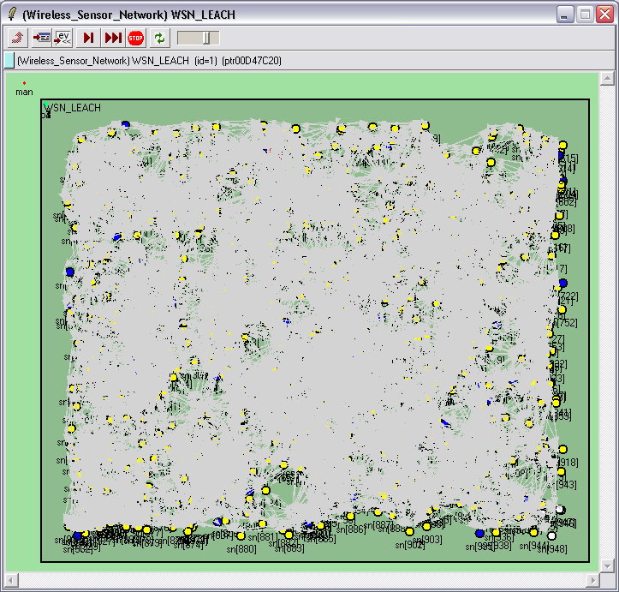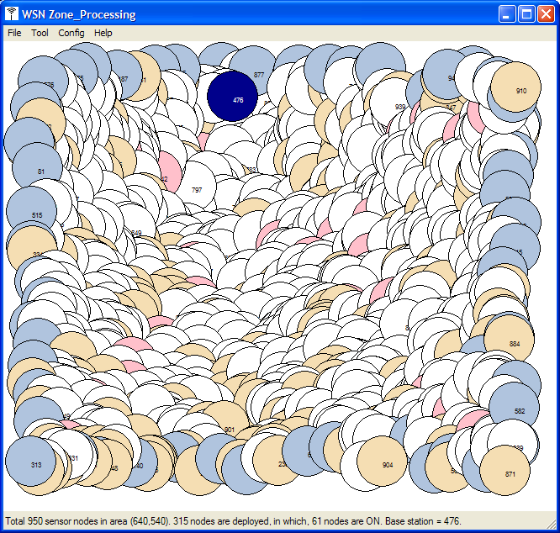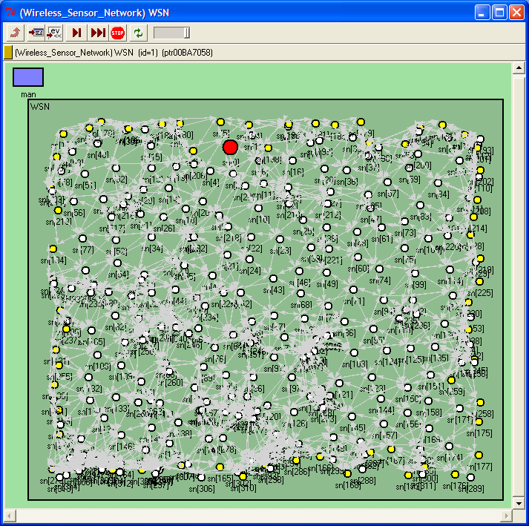
(a) (b) (c)
Figure 3: Removing redundant nodes
Figure 3 include a sequence of images illustrating the process of cleaning up redundant nodes. Image (a) is the initial sensor network, showing numerous nodes in the sensing area. Image (b) is an alternative representation of the network, with the redundant nodes shown as white nodes. Image (c) is the sensor network after redundant nodes have been removed.
As shown in Table 4, given a fixed size of the tracking area, when the number of nodes increases, OCO successfully reduce the redundancy by utilizing an increasingly smaller percentage of nodes. When the number of initially deployed nodes is 200, for instance, OCO requires 178 nodes to track the whole area (11% redundancy elimination); whereas when the total number of nodes is 1,000, OCO needs only 295 nodes to form the sensor network (or 71% redundancy removal). The number of border nodes in Table 4 will be discussed later.
Table 4: OCO’s reduction of sensor nodes
Number of nodes in the sensing area | OCO: number of nodes after redundancy removal + (number of border nodes) | % of reduction
200 | 178 (126 border nodes) | 11%
250 | 212 (136 border nodes) | 15%
300 | 230 (126 border nodes) | 23%
350 | 251 (131 border nodes) | 28%
400 | 269 (110 border nodes) | 33%
450 | 280 (101 border nodes) | 38%
500 | 285 (101 border nodes) | 43%
550 | 291 (86 border nodes) | 47%
600 | 287 (88 border nodes) | 52%
650 | 278 (83 border nodes) | 57%
700 | 299 (72 border nodes) | 57%
750 | 297 (74 border nodes) | 60%
800 | 294 (73 border nodes) | 63%
850 | 293 (73 border nodes) | 66%
900 | 279 (66 border nodes) | 69%
950 | 315 (61 border nodes) | 67%
1000 | 295 (60 border nodes) | 71%

      - Define border nodes
Nodes that are positioned along the border of the network area are called border nodes. To identify these nodes, we first apply the border detection algorithm (Table 5) to identify a list of points that traverse the border of the geographic image, called border points. Finally, find a minimum set of nodes in the Area_List that contain all the border points, which are the border nodes. (Note)
Table 5: Algorithm 3 (Finding the Border Nodes)
- For each pixel in the image, check if the color value =1.
- If true (meaning this pixel belongs to an object), scan all its neighbors to see if any of them having the color value = 0. If true, this pixel belongs to the border.

The process of identifying the border nodes is illustrated in Figure 4. Diagram 1 represents the initial collection of sensor nodes in the network. Diagram 2 represents an intermediate step, where border points are identified. Diagram 3 represents the resulting border nodes, without displaying the rest of the nodes.
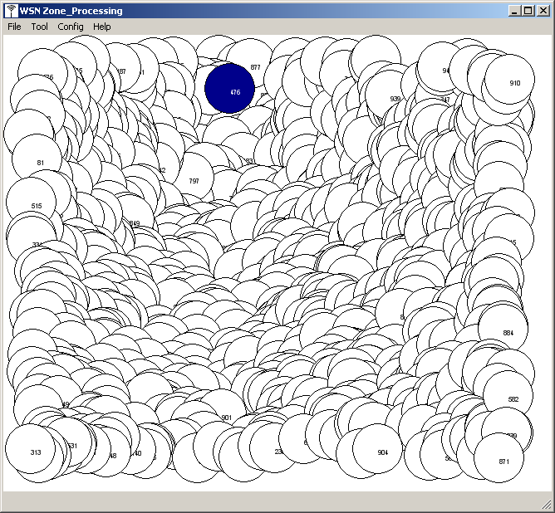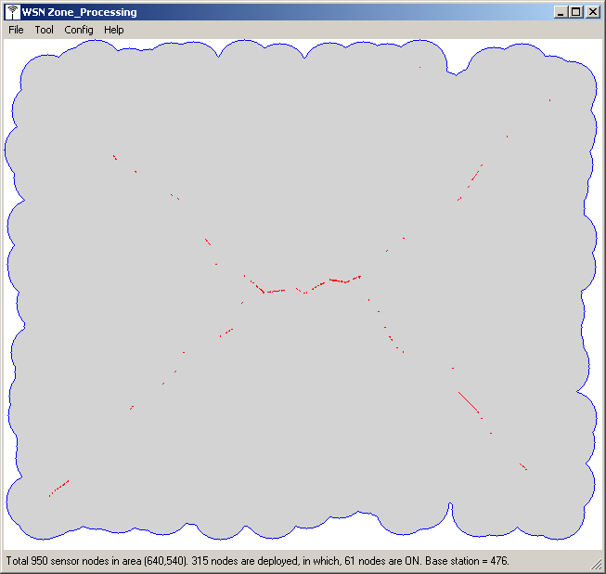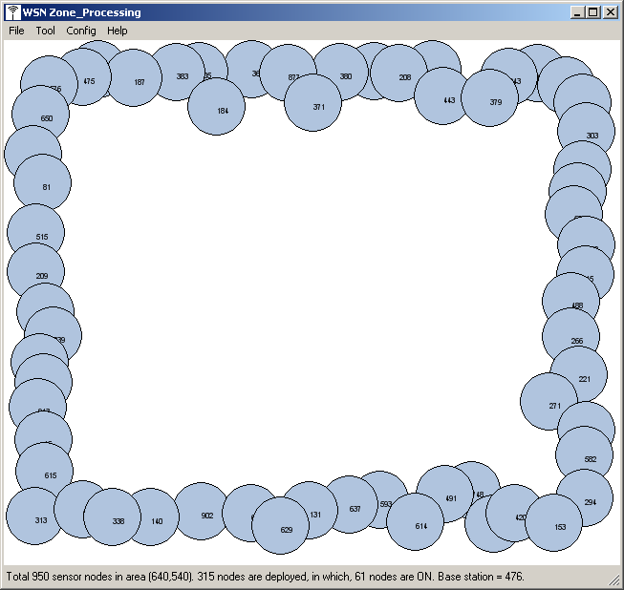
(1) (2) (3)
Figure 4: Detection of border nodes
As shown in Table 4, when the number of initially deployed nodes in a given area increases (that is, denser deployment), the number of border nodes selected by OCO decreases. For example, when the initial number of nodes is 200, OCO selects 126 nodes (63%) as the border nodes; whereas when the number of nodes is 1,000, the total number of border nodes is reduced to 60 (6%). Table 6 shows the percentage of nodes selected as border nodes, given different number of initially deployed nodes in the tracking area. The reason of this phenomenon is that, when the deployment is dense, the chance that each of the points in the tracking area is occupied by at least one sensor node increases, resulting in straighter border (rather than curved line of border in sparse deployment).
Table 6: Number of nodes vs percentage of border nodes
Number of nodes in the sensing area | OCO: number of border nodes | % of border nodes / number of nodes
200 | 126 | 63%
250 | 136 | 54%
300 | 126 | 42%
350 | 131 | 37%
400 | 110 | 28%
450 | 101 | 22%
500 | 101 | 20%
550 | 86 | 16%
600 | 88 | 15%
650 | 83 | 13%
700 | 72 | 10%
750 | 74 | 10%
800 | 73 | 9%
850 | 73 | 9%
900 | 66 | 7%
950 | 61 | 6%
1000 | 60 | 6%

      - Find the shortest path to the base
Algorithm 4 (Table 7) finds the shortest path (the least hops) to the base for each node in the Area_List.
Table 7: Algorithm 4 (Find the Shortest Path)
- Work only with nodes in the Area_List at the completion of Algorithm 2 (Table 3: Cleaning Up Redundant Nodes).
- Assign parent_ID = 0 for all nodes in the Area_List.
- Assign parent_ID = the base’s ID for all neighbors of the base and add these nodes to a list, called Processing_List. // The ‘neighbors’ of a node n is the set of nodes that are within n’s sensing area.
- For each node n in the Processing_List, consider all its neighbors. If the neighbor has parent_ID = 0, assign n as the neighbor’s parent_ID. Add the neighbor to the Processing_List.
- Repeat step 4 until all nodes are assigned parent_ID.
- After the loop, each node in the Area_list has a parent_ID. The base node uses messages of types M3 and M4 (Table 8) to send the parent-child relationship between nodes to all the nodes in the Area_list (aka. the non-redundant nodes).

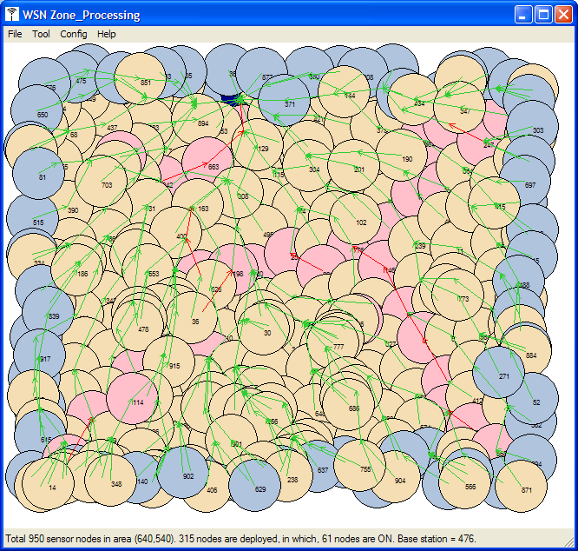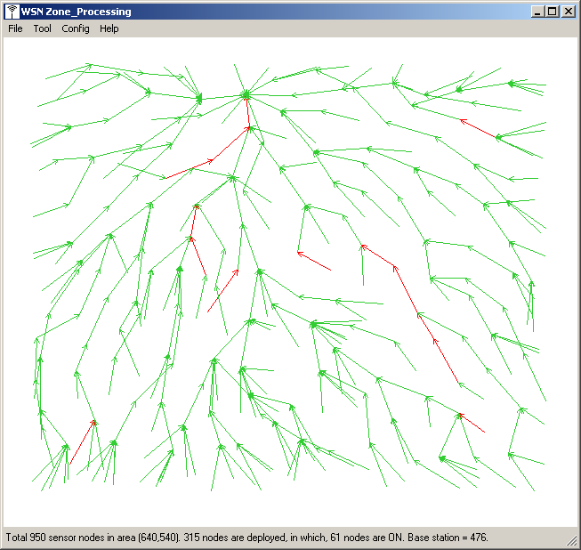
(a) (b)
Figure 5: Shortest path from nodes to the base
Figure 5 illustrates the forming of routing paths (image b) from a list of non-redundant nodes (image a). The paths are constructed by following the parent ID of each of the nodes until reaching the base. As shown in 5(b), the sensor network is structured as a tree, in which the base is the root. The simulations have shown that the number of hops from a given node n to the base depends on the distance in-between.
Once the parent-child relationship is established throughout the network, whenever a node wants to send a message to the base, it simply delivers the message to its parent. The message is then continually forwarded until it reaches the base. Algorithm 4 in Table 8 ensures that all the messages will reach the base through a minimum number of hops.
      - Assign roles to the sensor nodes

Table 8: Message types for assigning roles at the end of the Processing phase
Purpose | Message type
- Message from the base to notify the parent-child relationship between nodes | M3 = (message_id, base, all , message_type, child_id, parent_id), with message type = 3  // M3 is broadcasted by the base to notify each node in the network, including the border nodes, about its parent  M4 = (message_id, base, all, message_type, forwarding_node_id, child_id [ ] ), with message type = 4  // M4 is broadcasted by the base to notify each of the parent nodes in the network about its children
- Message from the base to the border nodes | M5 = (message_id, base, all, message_type, border_node_id), with message type = 5  // border_node_id is the node that will become a border node
- Message from the base to the redundant nodes | M6 = (message_id, base, all, message_type, redundant_node_id, time_to_synchronize, time_to_stay_awake), with message type = 6  // time_to_synchronize is used to set a time between the base and the redundant nodes when to wake up to wait for commands.  // time_to_stay_awake determines the interval for a redundant node to stay awake to receive commands from the base.
- Message from the base to the forwarding nodes | M7 = (message_id, base, all, message_type, forwarding_node_id), with message type = 7  // forwarding_node_id is the node that will become a forwarding node

In this last step of the processing phase, the base assigns various roles to the sensor nodes in the network, by broadcasting respective messages (M5, M6, and M7). First, it sends messages of type M5 (Table 8) to activate the set of border nodes. When a node n receives a message of type M5, it compares the field ‘border_node_id’ with its own id. If they are the same, node n is a border node. Node n will set its own sensor module and radio receiver module to ON (i.e., ACTIVE state).
The base broadcasts messages of type M6 to assign the role of redundant node to all the redundant nodes identified in Algorithm 2 (Table 3). The redundant nodes are initially OFF (i.e., SLEEP state). Periodically they wake up after a predefined long period (time_to_synchronize) to receive commands from the base. If there is no command or the commands are not related to them, they again switch to OFF after staying awake for a short period of time (time_to_stay_awake). In each message of type M4 (Table 8), two parameters, time_to_synchronize and time_to_stay_awake, are included in the messages. The former is used by the base to define a timer for the redundant nodes to wake up to wait for commands from the base; the latter is used to indicate how long the redundant node, after having woken up, should stay awake in order to have sufficient time for the commands from the base to arrive.
The rest of the nodes in the network are forwarding nodes, which are the intermediate nodes between a border node and the base. The base broadcasts messages of type M7 to notify the forwarding nodes, which have their sensor modules OFF but the radio receiver modules ON (i.e., FORWARD state).
A forwarding node may later become an active node (having both sensor and radio modules ON). During the tracking phase (section 3.3), when a forwarding node receives a message of type M9 (Table 9) from another node (a border or forwarding node), it turns its sensor module to ON, in anticipation of an intruding object.

  - Tracking phase
    - Message format definition
We define two message types for this phase, M8 and M9. The format of theses message types can be found in Table 9.
Table 9: Message types for the Tracking phase
Purpose | Message type
- Message from a node to the base to report intruding objects | M8 = (message_id, source, base, message_type, reporting_node_id, timestamp) with message type = 8  // reporting_node is the node that has detected the intrusion
- Message from an active node to nearby forwarding nodes to activate their sensor modules | M9 = (message_id, source, all, message_type) with message type = 9  // A forwarding node becomes an active node when its sensor module is ON

    - Operations
In the tracking phase, the sensor nodes all work together to detect and track intrusion objects, which are assumed to have come from the outside. Normally, only the border nodes’ sensor modules are ACTIVE. When a border node detects an object, it performs two actions: (a) It reports its own position to the base by sending a message of type M8 (Table 9) to its parent, which will forward that message to its own parent, and so on, until it reaches the base. (b) The border node then broadcasts a message of type M9 to all its neighbors. If the neighbor is a forwarding node, it will turn its own sensor module ON. That is, the forwarding node becomes an active node, in anticipation of the incoming intruder(s).
When a forwarding node detects an intruder, it performs similar actions as a border node does, by sending messages of type M8 to the base and M9 to the neighbors. In this way, the intruder is constantly tracked as long as it remains inside the tracking area of the sensor network. By receiving reports from the active nodes, the base continually keeps track of the intruder’s movement in the network.
      - Tracking multiple intruders
When it comes to tracking multiple objects, there exist two different types of sensor nodes. Type A can sense distinct multiple objects [11]; Type B does not have this capability. Type A of sensor nodes can accurately track each of the objects; thus it only needs to activate its neighbors by sending message M9 when a particular object is leaving its coverage area. Type B, on the other hand, can only detect whether there is any object at all within its coverage area. Without the capability to identify each individual object, type B of sensors need to periodically activate its neighbors by sending message M9, assuming one or more of the objects may have left its coverage area, until no more object is detected in its area.
Therefore, in a network equipped with type A sensors, an ACTIVE node that has lost an object will turn all its neighbors (forwarding nodes) to ACTIVE (assuming that the ‘escaping’ object will enter one of the neighbors’ sensing areas). (Note) If the neighbor detects any object, it will send its position to the base. Again right after it has lost an object, it turns all its neighbors to ACTIVE. The process will continue as long as an object is detected by the network. In the second case where type B sensors are used, an ACTIVE node will periodically turn all its neighbors (forwarding nodes) to ACTIVE. If the neighbor detects an object, it will send its position to the base and periodically turn its own neighbors to ACTIVE. In either case, if activated neighbors detect nothing, they automatically switch to the original state (FORWARD) after a predefined short interval.

  - Maintenance phase
    - Message format definition
In this phase, we define four message types to maintain the connectivity between parent and child nodes (M10 and M11), and for nodes to report emergency cases (M12 and M13). Message M14 is for the base to re-synchronize with the redundant nodes, by sending new values for the two parameters, time_to_synchronize and time_to_stay_awak. The message format can be found in Table 10.
Table 10: Message types for the Maintenance phase
Purpose | Message type
- Hello messages sent by a child node to report its energy level to its parent | M10 = (message_id, child, parent, message_type, energy_level), with message_type = 10
- Hello messages broadcasted by a parent to report its status to its children | M11 = (message_id, parent, all, message_type), with message_type = 11
- Emergency message type 1 (SOS):  When a node has lost its parent, it broadcasts an SOS message to the nearby nodes to trigger an adoption process. | M12 = (message_id, node_id, all, message_type, orphan_id), with message_type = 12
- Emergency message type 2 (BR):  When a node has lost one of its children (child_id), it sends a border-repairing (BR) message to the base to trigger a border-repairing process. | M13 = (message_id, sender_id, parent_id, message_type, border_id, energy_level), with message_type = 13
- Synchronization message for the base to synchronize with the redundant nodes (possibly with new time_to_synchronize and/or new time_to_stay_awak) | M14 = (message_id, sender_id, all, message_type, new_time_to_synchronize, new_time_to_stay_awake), with message_type = 14

    - Operations
During the tracking phase, one or more of the nodes may start to run out of energy. When that happens, the network becomes disconnected and unable to fulfill its mission of tracking intruders. To answer this challenge, the parent-child relationship between pair of nodes must be periodically maintained (using M10 and M11). When emergency occurs, M12 and M13 are used by a node to report a dead parent or a dead/dying child, respectively.
reconfigure the network when the need for topology change arises. Example cases of such changes are discussed below.
Case 1: Exhausted Nodes: When the energy level of a node is below a threshold, it turns all its children to SLEEP and sends a report to the base. When the base gets the report, it enters the processing phase to reconfigure the whole network, with dead nodes being removed and the network restructured.
Case 2: Damaged Nodes: After a predefined interval of time, nodes require their child nodes to send their IDs to them. Child nodes that do not report to their parents are assumed to be damaged and will be reported to the base. Similarly, if a child node did not receive any asking from its parent after the predefined interval of time (meaning the parent may be damaged), it will turn to SLEEP mode and wait for further command from the base.
Case 3: Re-positioned Nodes: When a node’s position changes (probably due to physical events, such as earthquakes, explosion, etc.), it will be considered as damaged by its parent (case 2.). After a node’s position is changed, it will: (a) automatically turns to SLEEP mode; (b) Broadcast a message indicating that its position needs to be updated. Any node that has received the broadcast will forward the information to the base, which then updates the given node’s position.
      - The Simple re-organization algorithm
This algorithm is used to locally re-organize the network whenever there is a change in the network topology.
Condition to run
- This algorithm is run by the Base to re-organize the sensor network when there is one forwarding node died (reported by the parent node when a child node does not reply to hellotoChildren message) or going to die soon (reported by the parent node when the energy level of the child node goes below the threshold).

Assumption
- The Base station has the map of all nodes (active or redundant) and the paths of all active nodes to the Base station.
- Because the random deployment of the sensor nodes, for an active node, there is a high probability that there will be several redundant nodes lying around this node.

Case 1: The dead (or dying) node is a forwarding node
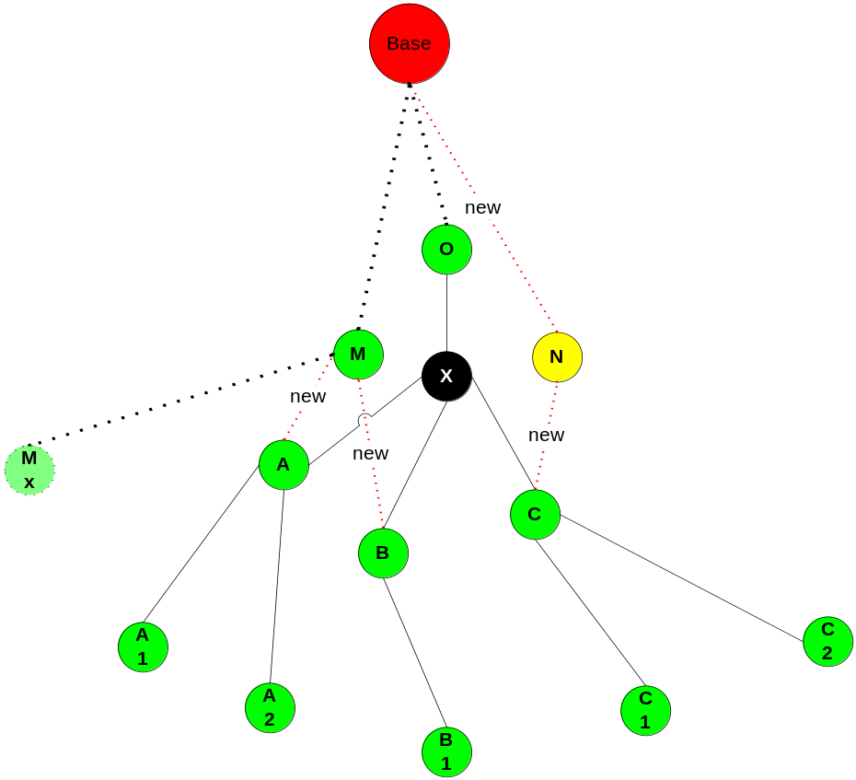

Figure 6: The dead node is the forwarding node
In the Figure 6 above, the dead node is node X. The parent node of X is node O report the dead node to the Base using emergency message type 2: M_BR.
The Base after a defined period, does not receive any other M_BR message around this area will trigger the Simple re-organization algorithm to rebuild the network.
Table 11: Simple re-organization given a dead/dying forwarding node
Algorithm 1
Put all the child node of the dead node X in a list l.

// To ensure the area originally covered by X will be covered
Find a redundant node Y having the distance to node X smaller than epsilon (const):
If Y does not exist --> dead node X make a big gap --> the base need to re-process (because some border nodes have to be employed to cover the gap).
Else (means Y can replace X with an acceptable gaps ), put Y to l.

Repeat
For each child node n in the list l
If (there is an active node m in the radio range of node n) AND (m is not in the list l) AND (m is not the child node of n)
Let m adopt n as a child node
Remove n from list l
Else
Find a redundant node m’ in the radio range of n
Assign m’ become the parent node of n
Remove n from list l
Add m’ to list l
Until l is empty
The Base uses message type M5 and M6 to inform all related node to the algorithm about its new parent and children nodes.

Example: In the Figure 6, at the beginning of the algorithm, list l contain 3 nodes: A, B, C
With node A: found node M is an active node in the radio range, let M adopts A. Remove A from list l.
With node B: found node M is an active node in the radio range, let M adopts B. Remove B from list l.
With node C: cannot find any active node in the radio range. Wake up node N is a redundant node. Let N be the parent node of C. Remove C from list l, add N to list l.
Continue the loop to find the parent node for all nodes in the list l.
Then the Base use message M5, M6 to inform all the nodes A, B, C, M, N … about their new parent and children.

Case 2: The dead (or going to die) node is a border node
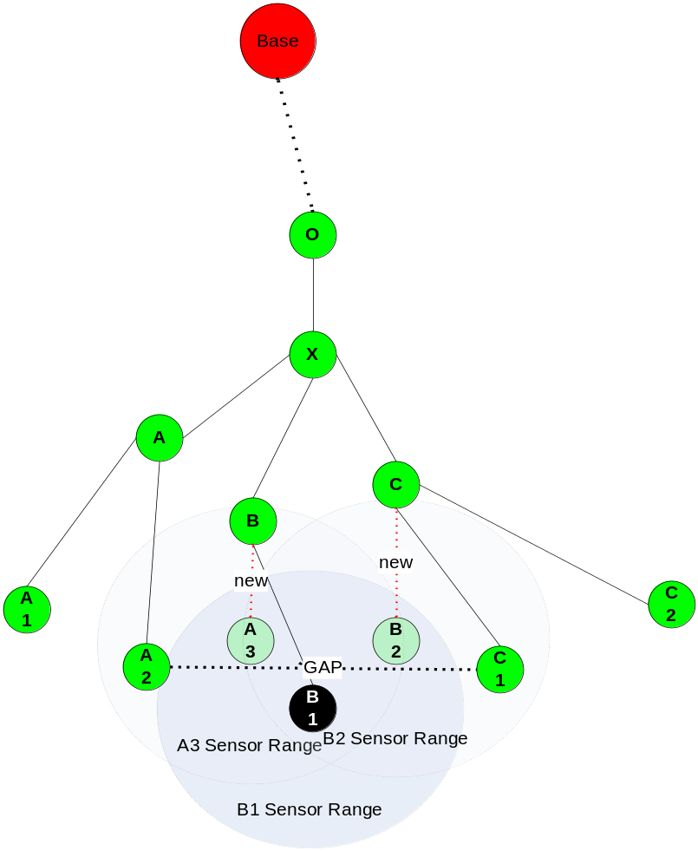
Figure 7: The dead node is a border node
In the Figure 7 above, the dead node is node B₁. The parent node of B₁is node B report the dead node to the Base using emergency message type 2: M_BR.
The Base after a defined period, does not receive any other M_BR message around this area will trigger the Simple re-organization algorithm to rebuild the network.
Table 12: Simple re-organization given a dead/dying border node
Algorithm 2
Find one or more redundant nodes around dead node n that
The new sensor range can cover the sensor range of the dead node n
Put the new nodes to list l
Run algorithm 1 on list l to find new path for the new nodes
The Base uses message type M6 and M7 to inform all related node to the algorithm about its new parent and children nodes.

Example: In figure 7, the Base wakes up 2 redundant nodes A₃ and B₂ to cover the sensor range of the dead node B₁. Then run algorithm 1 on the list contains A₃ and B₂ to find the new path:
With node A₃: found node B in the radio range and let B adopts A₃ as a new child.
With node B₂: found node C in the radio range and let C adopts B₂ as a new child.
Then the Base use message M5, M6 to inform all the nodes A₃, B₂, B, C about their new parent and children.
      - The Local re-organization algorithm
Condition to run
- This algorithm is run by the Base to re-organize a region of the sensor network when there are several nodes in a sub-tree reported to be died (reported by the parent node when a child node does not reply to hellotoChildren message) or going to die soon (reported by the parent node when the energy level of the child node goes below the threshold).
Assumption
- The Base station has the map of all nodes (active or redundant) and the paths of all active nodes to the Base station.
- All the border nodes are enumerated in an ascending order: 1, 2, 3….
- For a given sub-tree, the Base can easily figure out the border nodes (the leaves of that sub-tree) and base on the enumeration, the Base can find out the 2 border nodes on the two sides of those leaves.
- Because the random deployment of the sensor nodes, for an active node, there is a high probability that there will be several redundant nodes lying in this area.
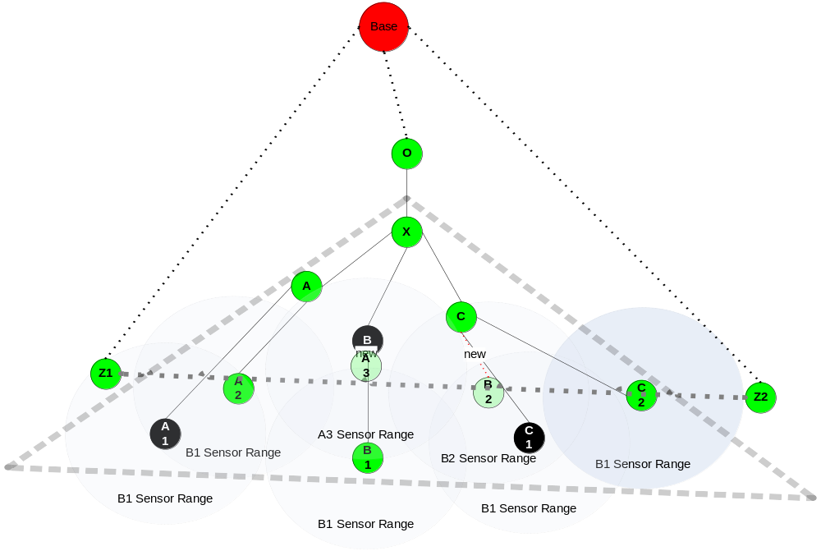
Figure 8: The number of death node in the sub-tree of O is higher than the threshold
Example: In Figure 8, the Base received 3 death nodes in the sub-tree of node O (reported by A, X and C using M_BR message type). The base then triggers the local re-organization algorithm on the sub-tree of O to rebuild the border and the path in this area.
Table 13: Local re-organization given multiple dead/dying nodes
Algorithm 3
Define the affected area: The rectangle that contains the smallest damaged sub-tree that covers all the dead nodes

Create the lists:
- Related nodes list l: This list contains all the nodes in the affected area including:
  - Nodes in the damaged sub-tree that has the dead nodes in the affected area
  - Redundant nodes in the affected area
  - Nodes that happen to be in the affected area but still have the link to the Base
- Orphan nodes list o: This list contains all the nodes in the damaged sub-tree.
- Redundant node list r: This list contains all the redundant nodes in the affected area.
- Alive node list a: This list contains all the nodes that happen to be in the affected area but has no relation to the damaged sub-tree.
- Processing list pl: This list is empty.

Locate the 2 border nodes on the two sides of the affected sub-tree, draw a line li between this two border nodes.
1. For each pixel p in line li
1.1 For each nodes n in the list a
If the sensor range of n covers p
Return to 1 and jump to the next pixel
1.2 For each node n in the list o
If the sensor range of n covers p
Add node n to the Processing list pl
Return to 1 and jump to the next pixel
1.3 For each node n in the list r
If the sensor range of n covers p
Add node n to the Processing list pl
Remove n from list r
Return to 1 and jump to the next pixel

//Now building the path for the nodes in the processing list pl
Repeat
2. For each node n in the list pl
//Hopefully there will be an alive node can adopt this node
2.1 For each node n’ in the list a
If the radio range of n’ covers n
Let n’ adopt n
Remove n from processing list pl
//No alive node can adopt the node, let’s check on the orphan list, hopefully there will be an active node can adopt this node, we won’t have to wake up a redundant node
2.2 For each node n’ in the list o
If the radio range of n’ covers n
Let n’ adopt n
Remove n from processing list pl
Add n’ to the end of the list pl
//The worst situation, no alive or active node can adopt this node, we have to wake up one redundant node to build the path for this node
2.3 For each node n’ in the list r
If the radio range of n’ covers n
Wake up n’ and let n’ adopt n
Remove n from processing list pl
Add n’ to the end of the list pl
Until pl is empty
The Base uses message type M5 and M6 to inform all related node to the algorithm about its new parent and children nodes.
The Base uses message type M4 to inform all the nodes remain in the list o to become redundant nodes.

Example: In figure 8, when the Base receives 3 the messages inform A₁, B, C₁ died, the Base actives the local re-organization algorithm on the affected area.
The Base can locate the smallest error sub-tree is the sub-tree with node X is the root.
Base on this sub-tree and the enumeration of the border nodes, the Base can locate Z₁ and Z₂ are the 2 border nodes on the 2 sides of the affected area.
The affected area will be the area in the gray bold dash rectangle.
Building the lists:
List l: X, A, A₂, A₃, B₁, B₂, C, C₂
List o: X, A, A₂, B₁, C, C₂
List r: A₃, B₂
List a: in this case is empty
List pl: empty
With node Z₁ and Z₂, draw a line li between Z₁ and Z_{2.}
For every pixel in the line li, find all the nodes with the sensor range cover the line. Put those nodes to list pl. We have list pl: A₂, B₁, B₂, C₂
Now we can run the algorithm on list pl to rebuild the path to the Base for all nodes.

- SIMULATION AND EVALUATIONS
In evaluating the performance of OCO, two other methods are selected as comparisons: the Naive method (DC, Direct Communication) and the cluster-based method (LEACH). The tool that is used for simulation is OMNET++ [10]. It is an open-source, component-based, modular and open-architecture simulation environment with strong GUI support and an embeddable simulation kernel. OMNET++ allows the builder of a simulation environment to place the simulated modules at any place. This capability enables us to simulate the random location feature of a sensor network, as well as build moving objects.
  - Models and Tools
The simulation models we have built to test the performance of the sensor network consist of three sub-models: a sensor-node model, a sensor-network model, and an intruder-object model.
    - Simulating a sensor node
The Sensor Network Research Group at Louisiana State University has defined a generic sensor node [8]. Based on this generic design, we have built a simulated sensor node as illustrated in Figure 9.
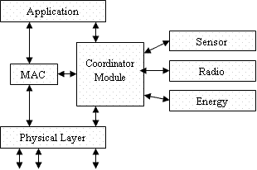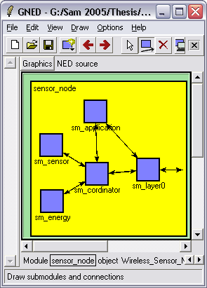
Figure 9: The sensor-node structure and its simulation on OMNET++

The Physical Layer module represents the physical layer of a sensor node. It is responsible for making connections between the node and its neighbors, and forwarding messages from a higher layer to its neighbors, and vice versa. The MAC module represents pre-processing packet layers. It consists of gates and queues. When the queue is full, it deletes some of the oldest messages in the queue to make room for new messages. It helps to evaluate performance of the node. In the current simulation, we do not consider those features, so this module is disabled to speed up the simulation. The Application module represents the application layer. Note that, each time after sending a message, the module automatically sends a DECREASE_ENERGY message to the energy module (through the coordinator) to let the module decrease the energy by a number of energy units. The Coordinator module is an interface to connect all modules together. It categorizes an incoming message in order to deliver it to the right module. The Sensor module represents the sensor board in a node. If the SENSOR_SWITCH parameter is ON (=1), the module consumes energy. It is automatically OFF after an interval of sensing nothing. The Radio module represents the radio board in a sensor node. If RADIO_SWITCH parameter is ON (=1), the module consumes energy. The Energy module represents battery in a sensor node. If the module receives a DECREASE_ENERGY message, it decreases the energy level by a number of units.
    - Simulating an intruder object
In a real sensor network, the sensors continuously try to detect the object. In the simulation, the sensing behavior is simulated by first creating connections between the object and the sensor nodes near it. ACTIVE sensor nodes whose sensing zone covers the object will periodically receive from the object a SENSOR_INFO message.
A simulated intruder object needs only two modules: the ObjectApplication module on top of the Physical Layer module [8]. The Physical Layer module is similar to the Physical Layer module of the sensor node. However, the connections in the intruder object are re-created after each movement. The ObjectApplication module helps the object to move, by reading position data from a text file.
    - Simulating a network with intruder objects
A sensor network includes a set of sensor nodes. To simulate such a network, we need a module called manager [8] to help simulate tasks such as making connections among the nodes, making connections between the nodes and the object, and saving simulation results, etc. To construct the sensor network, the manager module starts by first reading data from a file, which stores network configuration information, including sensor node and object positions, tasks, and routing information, etc. It then makes connections among nodes, by checking the coverage zone of all nodes to see if any node is in the zone and, if yes, making connections between the node and the covered nodes.
Each time an object moves, the manager module will consider if any node is in the object’s zone, within which a node can sense the object. If such a node exists, the manager module creates a connection between the object and the sensor node, so that the object can send the SENSOR_INFO message to the node. The manager module also handles the broadcast sent by the base, by creating connections between the base and all the nodes. Finally, the manager module controls the power switch (POWER_SWITCH parameter) of all nodes in the network.
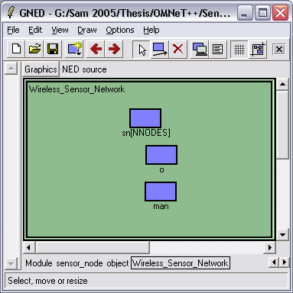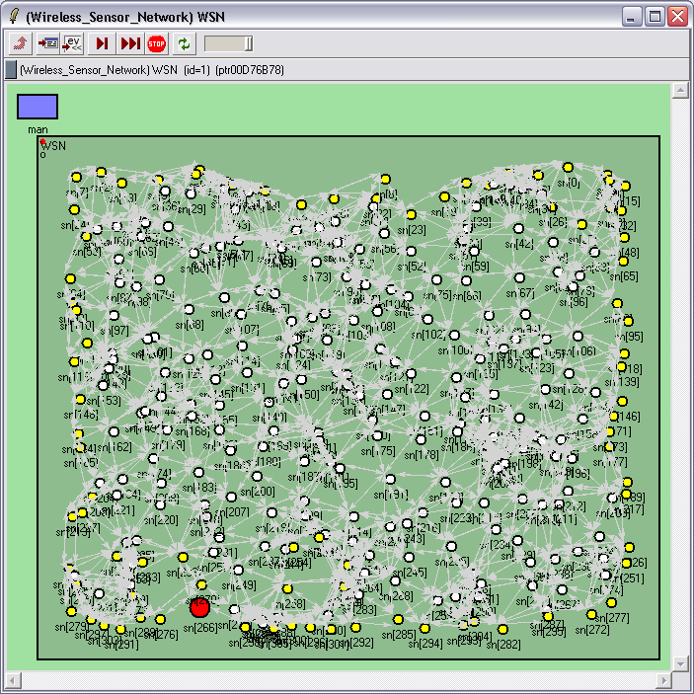
(a) (b)
Figure 10: A sensor network with an intruder
Figure 10 shows an OMNET++ sensor network structure with one intruder object (a), and its corresponding simulated network (b).
  - The Metrics
There are overall four types of metrics that are considered when comparing the performance of the three selected methods:
- Total energy consumption is the total energy that the network spends in a given scenario.
- Accuracy is a percentage of the number of detected object positions of the given method over the number of detected positions of DC. The underlying assumption is that the DC method, due to its direct communication to the base, should exhibit the highest accuracy in detecting objects.
- Cost per detected point is the ratio between energy consumption and the number of detected positions. It represents the average number of energy units that are spent for a detected position.
- Time before the first dead node is the time when the first node of the network runs out of energy. This matrix is a significant indication of the sensor network’s ‘well-being’ or longevity.
    - Energy consumption calculation
There are three modules contributing to the energy consumption in a node: the radio module, the sensor module, and the MCU (Micro Controller Unit). The radio module is responsible for wirelessly communication among nodes. A typical radio module used in wireless devices is shown in Figure 11 (redrawn from [4]).
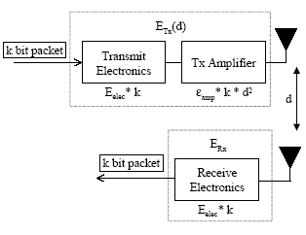
Figure 11: Radio model for a wireless device
The Transmit Electronics represents electronics circuit performing signal modulation. Tx Amplifier is used to amplify the modulated signal and output it to the antenna. The Receive Electronics is used to decode the modulated signal. E_{elec} is the energy needed for modulating or demodulating one bit of the circuits. Є_{amp} is the energy for the amplifier circuit to transmit one bit to an area of radius d = 1 meter (i.e., πd²). In a real device, the transmit module (Transmit Electronics and Tx Amplifier) normally stays in sleep mode. It only wakes up when there is any bit that needs to be sent. The receiver module (Receive Electronics) performs the reverse function. It needs to be ON when waiting to receive messages.
The formulas for sending a k-bit message are shown in Figure 12 and Figure 13 (redrawn from [4]). E_{Tx}(k,d) represents the energy needed to spread k bits to an area of radius d, while E_{Rx}(k) the energy needed to de-modulate k bits. The 2nd formula in the two figures is a re-writing of the respective 1st formula per Figure 11.
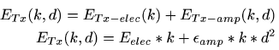
Figure 12: Energy consumption formula for sending a k-bit message to a distance d

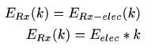
Figure 13: Energy consumption formula for receiving a k-bit message

Table 14: Current of boards in sensor node MICA2DOT (MPR 500)
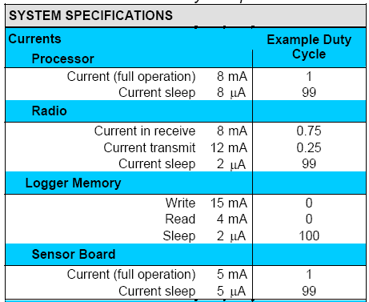
The sensor board, the MCU (CPU board, Memory board), and the radio board may work in one of two modes. In the sleep mode, the energy dissipation is almost zero. The full action mode consumes energy as shown in Table 8 (redrawn from [6]). mA means milli-ampere, and µA micro-ampere. We use the assumptions in [4] as the basis when calculating the energy dissipation for our simulations, which are summarized in Table 15. (Note)
Table 15: Parameters related to calculation of energy consumption
- Energy consumption for modulating or demodulating one bit:
Eelec = 50nJ/bit
- Energy consumption for spreading one bit to an area of radius r = 1 meter (i.e., πm²):
Єamp = 100pJ/bit/ m² = 0.1nJ/bit/m²
- Data rate = 2000bits/s
- Data package size = 2000-bit
- Signal package size = 64-bit
From Table 14, we deduce that the current of the MCU board in full operation is equal to that of the radio board in the receiving mode, and the current of the sensor board in full operation is around 2/3 of the current of the radio board in the receiving mode. Derivations of the remaining parameters for calculating energy consumption are shown below:
- E_{Rx_data} = E_{elec}* k-bit/message = 50nJ/bit * 2000 bits/message = 100 µJ/message
Meaning: The radio board consumes 100 µJ for each received data message.
- E_{Rx_signal} = E_{elec}* k-bit/message = 50nJ/bit * 64 bits/message = 3.2 µJ/message ~= 3 µJ/message
Meaning: The radio board consumes 3 µJ for each received signal message.
- E_{Tx_data} = E_{elec}* k-bit/message + Є_{amp}* k * d²
= 50 nJ/bit * 2000 bits/message + 0.1 nJ/bit*2000 bits/message * d² = (100 µJ + 200* d²)/message
Meaning: The radio board consumes (100 + 200*d^2) µJ for transmitting a data message to a distance d.
- E_{Tx_signal} = E_{elec}* k-bit/message + Є_{amp}*k* d²
= 50 nJ/bit * 64 bits/message + 0.1 nJ/bit*64 bits/message* d² = (3 µJ + 6.4* d²)/message
Meaning: The radio board consumes (3 + 64* d²) µJ for transmitting a signal message to a distance d.
We assume that the optimized communication radius of nodes is 60m. So:
- E_{Tx_data} = 2000(bit)*(50(nJ) + 0.1(nJ)*60*60) = 820 µJ/message
Meaning: The radio board consumes 820 µJ for transmitting a data message to distance d<= 60m.
- E_{Tx_signal} = 64(bit)*(50(nJ) + 0.1(nJ)*60*60) = 26.2 µJ/message ~= 26 µJ/message
Meaning: The radio board consumes 26 µJ for transmitting a data message to a distance d<= 60m.
- E_{Radio} = Eelec * data_rate = 50nJ/bit* 2000 bits/s = 100 µJ/s
Meaning: If the radio board is in receiving mode, it consumes 100 µJ at each second.
- E_{Sensor} = E_{Radio} * 2/3 = 66 µJ/s
Meaning: if the sensor board is in full operation mode, it consumes 66 µJ at each second.
In general, the MCU is in sleep mode, it just switches to active when having an external interrupt. Therefore, in the simulation, we assume that the processor is in sleep mode. It turns to full operation when having an event. It means when creating a new message, energy consumption is calculated as follows:
- E_{MCU_data} = 2000(bit)*50(nJ) = 100 µJ/message
Meaning: The MCU board consumes 100 µJ for creating a data message.
- E_{MCU_signal} = 64(bit)*50(nJ) = 3.2 ~= 3 µJ/message
Meaning: The MCU board consumes 3 µJ for creating a signal message.
Derived from the above calculations, Table 16 summarizes the operations and their respective consumed energy.
Table 16: WSN Energy consumption summary table
Create/Receive a data message  Create/Receive a signal message | 100 µJ  3 µJ
Send a data message (d<= 60m)  Send a signal message (d<=60m) | 820 µJ  26 µJ
Send a message (d > 60m) | 100 µJ + 0.1* d²
Sensor board (full operation) | 66 µJ/s
Radio board (idle/receive mode) | 100 µJ/s

      - Energy consumption calculation in DC

Table 17 summarizes the states of the various boards in DC. All the sensor boards are always active. When a node senses an object, it transmits the sensing information to the base directly. Nodes do not need to communicate with each other, so the radio boards are in sleep mode.
Table 17: Summary of states in DC
Sensor board | Active
Radio board | Sleep; wake up for transmitting only.
MCU board | Sleep; wake up for creating messages only.

      - Energy Consumption calculation in LEACH
In LEACH, the sensor boards of all the nodes are in full operation. When a node senses an object, it transmits the information to its cluster head, which then forwards the information directly to the base. A cluster head needs to receive messages from its clients, so the radio board of a cluster head is in the receiving mode. The radio boards of other nodes are turned off (in sleep mode).
We know that one of the weaknesses of LEACH is that nodes do not always get invitation to join a cluster, because there is no cluster head in their zone (called wild nodes). To simulate such a scenario, the sensor boards of all nodes that do not enroll with any cluster head are turned off. The states of various nodes in LEACH are summarized in Table 18.
12.
Table 18: Summary of states in LEACH
 | Head nodes | Client nodes | Wild nodes
Sensor board | Active | Active | Sleep
Radio board | Receive | Sleep; wake up to transmit only | Sleep
MCU board | Sleep; wake up to create messages only. | Sleep; wake up to create messages only | Sleep
      - Energy Consumption calculation in OCO
In OCO, there are three types of nodes: border nodes, forward nodes, and redundant nodes. The states of various nodes in OCO are summarized in Table 19.
Table 19: Summary of states in OCO
 | Border nodes | Forwarding nodes | Redundant nodes
Sensor board | Active | Sleep | Sleep
Radio board | Receive | Receive | Sleep
MCU board | Sleep; wake up to create messages only | Sleep; wake up to create messages only | Sleep
The radio boards of all nodes are in receiving mode because nodes in OCO need to exchange data. The sensor boards of all border nodes are in full operation. Forwarding nodes, however, have the sensor boards off. A forwarding node is turned ON when receiving a message from one of its neighbors. The redundant nodes are used as backup nodes. They initially have all boards in sleep mode.
    - Calculation of object tracking accuracy
According to [9] (page 36), a sensor network with all nodes in the tracking mode (i.e., the sensor board is in full operation mode) is a useful base for comparison, because it provides the best possible quality of tracking. Therefore, we consider the total number of detected points in this case as 100%, and call it the standard number of detected points. The accuracy of each method is a percent ratio between the number of detected points of the method and the standard number of detected point.
    - Cost per detected point
Cost per detected point is a ratio between the total energy consumption and the total number of detected points of the method.
    - Time before the first dead node calculation
The manager module periodically (every 0.1s) checks all nodes in the network to see if any node has run out energy. If it finds any, the simulation time at that moment will be recorded as the time before the first dead node.
  - Simulation Environment
The simulation environment is built as an area of 640x540. The number of nodes in the network is 200, 250, 300, 350, 400, 450, 500,550, 600, 650,700, 750, 800, 850, 900, 950, and 1000, with 2J (Joule) of energy for each node. The sensing radius of each node is 30m and the communication radius is 60m. Intruder objects are supposed to move by traversing specific paths and come from outside of the network area. Data aggregation is effective.
Figure 14 shows the four different paths used in the simulations. The moving paths of objects are created by drawing images. A MATLAB program reads the images and generates appropriate text files of positions of the path images.
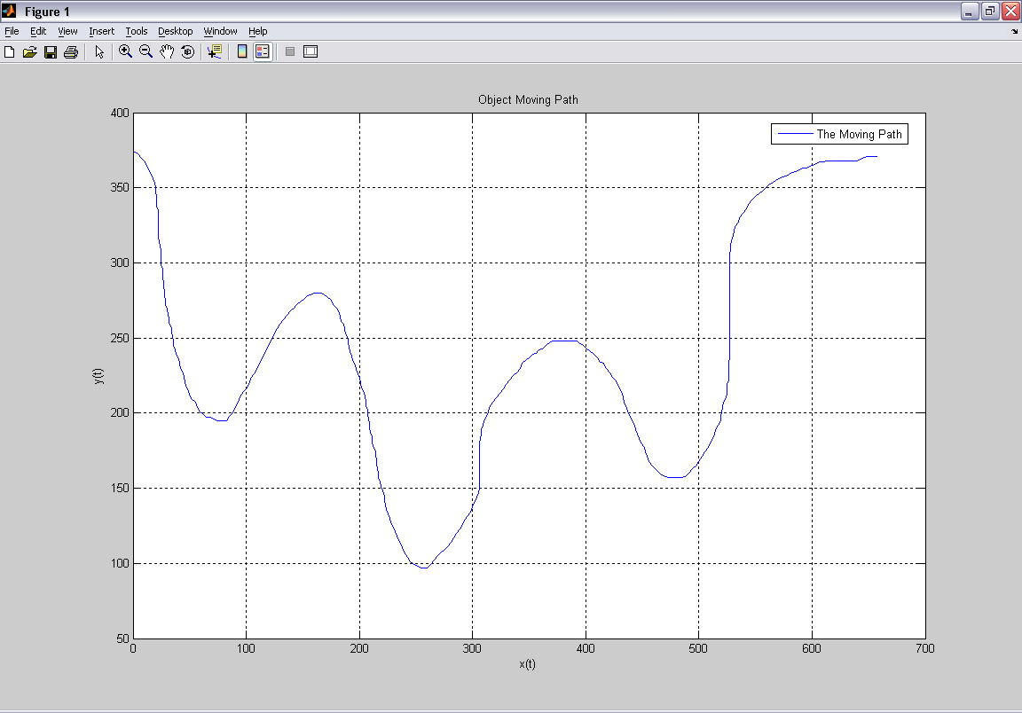 | 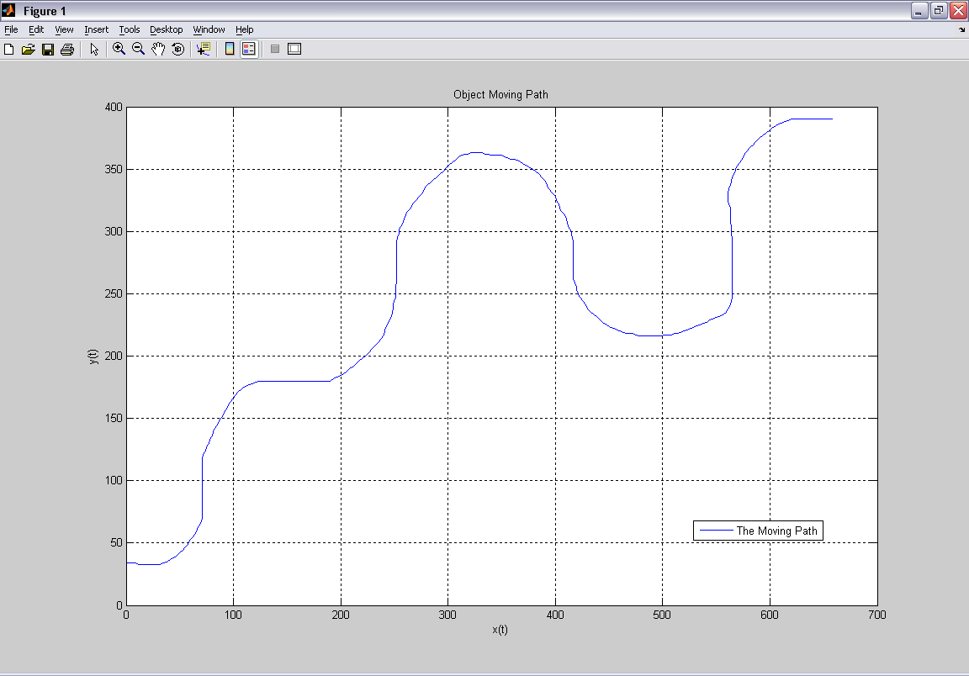 | 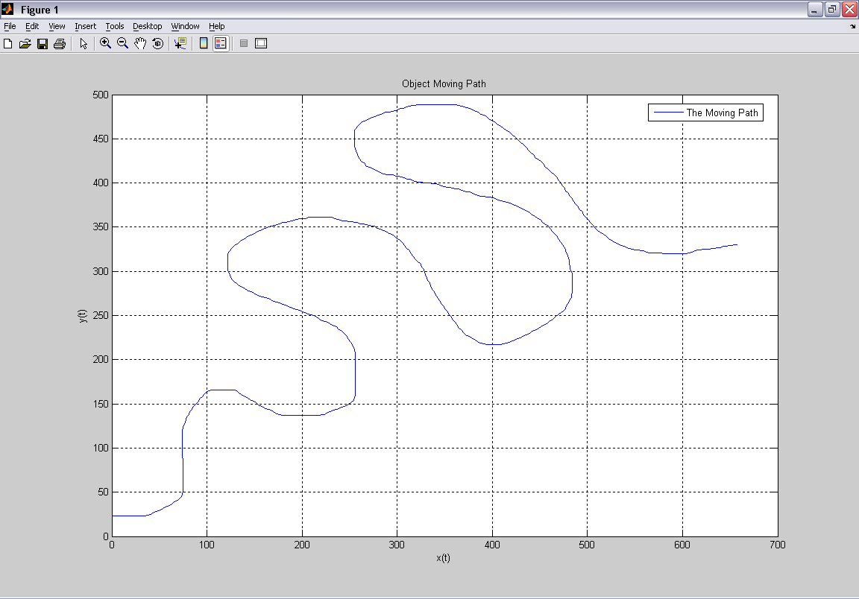 | 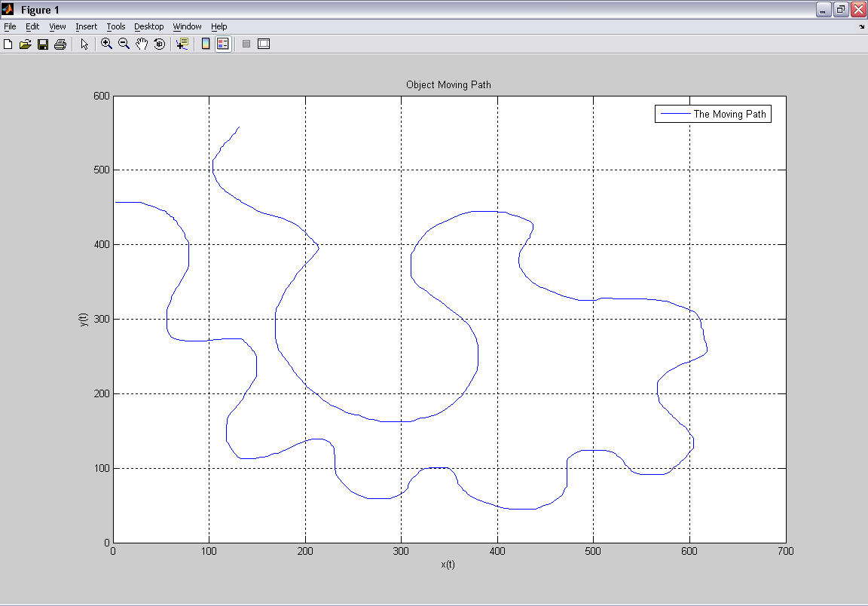
Case 1: Path across | Case 2: Diagonal path across | Case 3: Diagonal zigzag path | Case 4: Along-the-border path
Figure 14: Four paths for different cases of intrusion
  - Simulation Phases
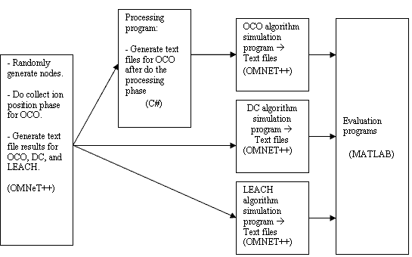
Figure 15: The simulation process
The simulation process is illustrated in Figure 15 and summarized below:
- Use an OMNET++ program called position collection to generate 200, 250, 300, 350, 400, 450, 500, 550, 600, 650, 700, 750, 800, 850, 900, 950, and 1000 nodes randomly. The user selects a node to be the base station in each configuration. The program will simulate the position collection phase. After the simulation, a text file is generated. The file contains node IDs, the base ID, and energy.
- The processing program will read the text file, perform all processing and then generate result files for OCO. These files describe which nodes are deployed, the mission of each node in the network, the energy level, etc.
- Three OMNET++ programs called DC, LEACH, OCO read these files and apply appropriate algorithm(s) for the simulations. The results of the simulations are text files, which contain information such as the detected points, the energy level of each node, and the time before first dead node.
- Finally, MATLAB programs are used to analyze and evaluate the simulation results.
- RESULTS
  - The Base Cases: no intruder objects
In this case, two metrics, energy consumption and time before the first dead node, are measured. The results of running the three methods in 9,000 seconds of simulations are shown in Figure 16 and Figure 17.
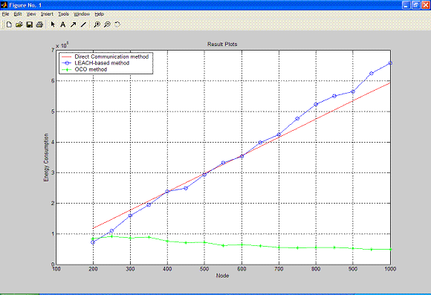
Figure 16: Energy Consumption (no intruder)

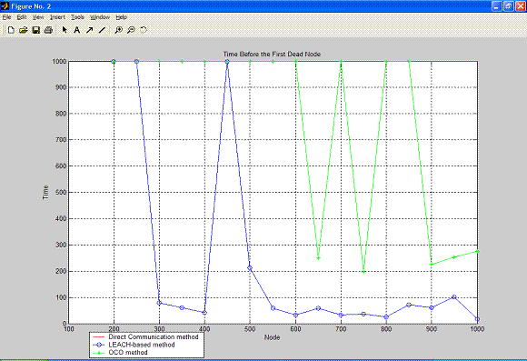
Figure 17: Time before the first dead node
In Figure 16, when the number of nodes increases, the energy consumption of OCO goes to a constant, delivering much better result than the other methods. The only exception is when the number of nodes is 200. The reason is that, when the number of nodes increases, the size of the border in OCO decreases (fewer gaps between border nodes and straighter borderline). The minimum is reached at 950. Time before the first dead node, as illustrated in Figure 17, shows OCO lasts longer than LEACH in all cases. DC shows superior performance, but it is not a practical method, and is used as a base of comparison.
  - Tracking Case A: one intruder object
In this case, the simulation results are divided into four cases. Each of the cases represents the collected metrics given a particular path of the moving object (Figure 14), with the moving speed being 10 points/s. In these scenarios, nodes in OCO only need to activate their neighbors when the object is leaving its coverage area. Due to the limited space, evaluation results of this case are not included. The results, however, are compatible with the ‘multiple objects’ cases below.
  - Tracking Case B: multiple intruder objects
Scenarios in this case are similar to the ‘single object’ case above, with the difference that multiple intruder objects are present in the environment. Each of the objects traverses a different path (Figure 11), with the same speed at 30 points/s. Type B sensors are used in the simulations. (Note)
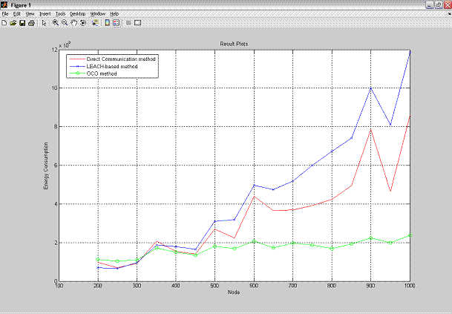
Figure 18: Energy consumption (multiple intruders)
As shown in Figure 18, when the number of nodes is greater than 300, OCO consumes much less energy than the others, and it appears to reach a constant when the number of nodes is 500 or higher. At 1,000 nodes, the energy dissipation of OCO is about 1/4 of DC and 1/6 of LEACH. The reason that the energy consumptions of LEACH and OCO appear to fluctuate at 600 and 900 is that, in these cases, the base happens to be far from the moving paths. As shown, even in those cases, OCO is more stable than the others.
As shown in Figure 19, the accuracy of OCO is compatible to DC in most of the cases. LEACH, although showing very good results when the number of nodes is higher than 700, exhibits less stable results when the number of nodes is lower than 700.
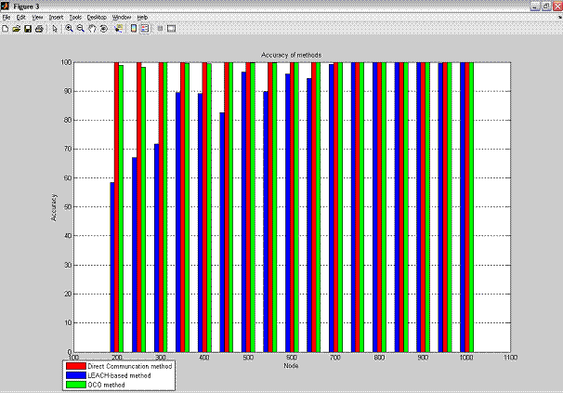
Figure 19: Accuracy comparison (multiple intruders)

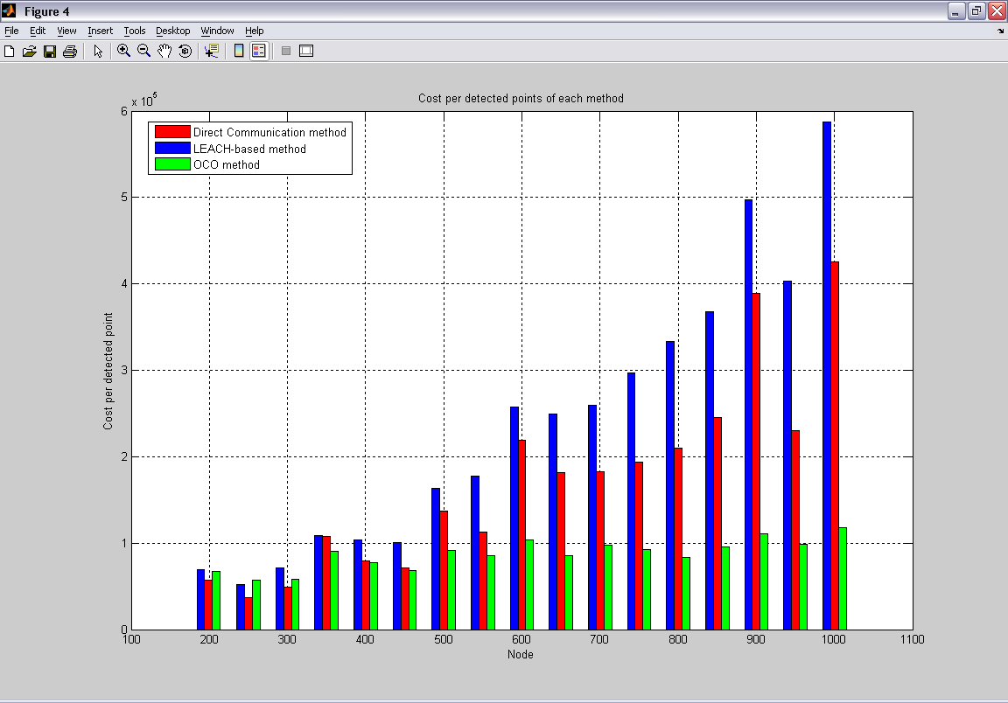
Figure 20: Cost per detected point (multiple intruders)
Figure 20 shows the cost per detected object position. OCO’s cost is the lowest in all the cases when the number of nodes is greater than 300, and the costs seem to remain constant. The cost of LEACH appears to increase relative to the number of nodes.
As shown in Figure 21, the time before the first dead node appears to be “fluctuating” across the cases, mainly because that, depending on the relative distance between the intruding object and the base, one of the nodes may run out of energy. Still, OCO lasts longer than LEACH in all cases.
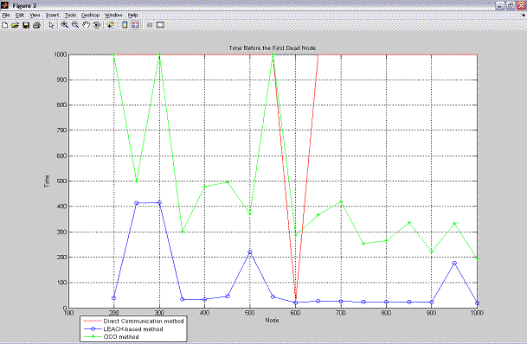
Figure 21: Time before the first dead node (multiple intruders)

- REFILLABILITY AND SECURITY: PRELIMINARY ANALYSIS
  - REFILLABILITY OF OCO
In addition to energy efficiency and accuracy, one of the main strengths of OCO is its self-organizing capability, which makes OCO re-configurable when some of the sensor nodes cease to function.
We believe that OCO’s re-configurability will lead to its easy maintenance, meaning that when some of the nodes in an OCO network have ceased to operate (possibly due to energy exhaustion or physical damage), new nodes can be refilled to the tracking area. The OCO method will then be able to use the old and the new sensor nodes to dynamically construct a new network to continue its assigned mission. This feature of refillability has the potential of increasing the longevity of an OCO-based WSN. We plan to further evaluate this feature, by developing simulation-based evaluations to measure the efficiency and cost of OCO in reviving an existing sensor network whose functional lifetime is about to end due to a high percentage of dead nodes.

  - SECURITY IN OCO
To further improve the OCO method, the proposed work will focus on two important areas: refillability and authentication, which are to be discussed in the next section.
Security in WSN is faced with six primary challenges [1]:
- A wireless sensor network typically has limited communication bandwidth and transmission power. An attacker may exploit either of these limitations to bring down the normal operation of the network.
- A sensor node in a wireless sensor network usually has limited resources, such as slower CPU and limited memory. Security algorithms requiring heavy computation will not be efficient when deployed in such sensor nodes. Lightweight and efficient algorithms are required.
- Wireless sensor networks tend to be very large and densely deployed, creating problems such as redundant coverage and the need to have multi-hop communications.
- There usually exists no fixed infrastructure in a wireless sensor network. For example, the sensor nodes may be thrown off from an airplane flying over the area to be surveilled.
- Prior to the deployment of the sensor nodes, the network topology may be unknown.
- The sensor nodes are typically deployed in a hostile environment or even in an area controlled by the enemy, so they are subject to high risk of physical attack.
In addition, the sensor network usually operates in hostile environments. For example, the sensor network may be prone to impersonation attacks, possibly launched by thieves or terrorists attempting to enter a restricted area that is monitored with the aid of a sensor network. Furthermore, the data packets transmitted across the network may be prone to polluted blocks attacks, meaning the attacker may re-organize or modify some of the data bytes. Encryption alone is not sufficient to protect a sensor network against impersonation or polluted blocks attacks.
In the context of WSN security, we focus our attention on the following security features: origin integrity (i.e., authentication), data integrity, confidentiality, and availability. When a sensor node communicates with another sensor node or with the base station, the communicating parties must be authenticated to ensure origin integrity. The feature of data integrity requires that the message exchanged in between the parties must not be subject to modification attacks. In addition, the message exchanged is confidential when only the destination node(s) would be able to access the content of the message. Last but not the least, the WSN should be protected from Denial of Service attacks rendering the base station or the whole WSN to be unavailable.
So far our focus has been on the authentication feature of OCO.
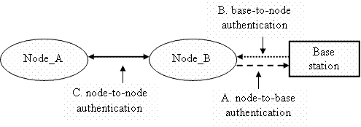
Figure 22: Three types of authentications in a wireless sensor network
As illustrated in Figure 22, there exist three generic types of authentications in a WSN: (A) Node-to-base authentications, meaning the node is being authenticated by the base station; (B) base-to-node authentication, meaning the base is authenticated by a sensor node; (C) node-to-node authentication, in which both the authenticator and the authenticated are sensor nodes.
- Node-to-base Authentication: Because a base station is typically more powerful (in terms of processor, memory, etc.) than a simple sensor node, the base station may rely on more rigorous but computation-intensive algorithms (such as digital signatures) when authenticating a sensor node.
- Base-to-node authentication: On the other hand, it is commonly believed that standards-based methods such as digital signatures and certificates will incur heavy computational overhead and thus inappropriate as the authentication methods running on the sensor node. Instead, lightweight authentication protocols, such as the key-pair authentication methods surveyed in [1] and [7], would be more appropriate as the authentication method on the sensor node.
- Node-to-node authentication: In this case, both the authenticator and the authenticated are sensor nodes. Node-to-node authentication is faced with challenges similar to the base-to-node authentication.
For message authentication in OCO, we suggest to append a Message Authentication Code – MAC of the whole original message to each message. The MAC value is generated based on the assumption that there is a shared key between any two communicating nodes and the hash algorithm may be HMACSHA1. The new message format will have the general form as follows M’ = (M, MAC(M)).

- SUMMARY AND FUTURE WORK
We have devised a method, OCO (Optimized Communications and Organization), for efficient target tracking in wireless sensor networks, and have evaluated its performance in various simulation scenarios against two other methods (DC and LEACH). Based on the evaluations, OCO appears to consume less energy than the other methods while achieving superior accuracy.
In addition to its efficiency, the main strengths of OCO include easy maintenance, meaning that, when an active node is dead, it can be replaced by one of the redundant nodes. In extreme scenarios, when too many nodes have exhausted their energy, new nodes can be refilled to the tracking area and the OCO method will be able to dynamically build up a new network.
The sensor network usually operates in hostile environments. Therefore, it is critical to add security features to OCO. Part of our future work is to add to OCO authentication and other security features (such as data integrity, confidentiality, etc.). We are in the process of devising a secure version of OCO.

ACKNOWLEDGEMENTS
The authors are partially supported by the University of Houston – Clear Lake (FRSF #859), the Institute for Space Systems Operations (ISSO), and the National Science Foundation (DUE 0311592).

VITA
T. Andrew Yang is currently an associate professor of computer science and computer information systems, in the University of Houston – Clear Lake, Houston, Texas, US. His research interests include Computer Security, Network Security, Mobile Ad Hoc Networks, and Wireless Sensor Networks.


Sam Tran is a graduate student of Computer Engineering, in the University of Houston – Clear Lake. His research interest focuses on efficient algorithms for wireless sensor networks.

Duy Cao is a graduate student of Computer Science, in the University of Houston – Clear Lake. His research interest focuses on wireless sensor networks.

Tuan Anh Nguyen is a graduate student of Computer Information Systems, in the University of Houston – Clear Lake. His research interests include Mobile Ad Hoc Networks and Wireless Sensor Networks.


REFERENCES
[1] Camtepe, Seyit A., and Bulent Yener (2005). “Key Distribution Mechanisms for Wireless Sensor Networks: Survey report”. Rensselaer Polytechnic Institute. http://www.cs.rpi.edu/research/pdf/05-07.pdf
[2] Chuang, S. C. (2005) “Survey on Target Tracking in Wireless Sensor Networks”. Dept. of Computer Science – National Tsing Hua University. Retrieved 11/8/2005 at http://mnet.cs.nthu.edu.tw/paper/934355tbl/050526--Survey%20on%20Target%20Tracking%20in%20wireless%20sensor%20newworks.pdf.
[3] Guo, Weihua, Zhaoyu Liu, and Guangbin Wu (2003). “An Energy-Balanced Transmission Scheme for Sensor Networks”. Dept. of Software and Information Systems - Univ. of North Carolina at Charlotte. Retrieved 9/8/2005 at http://www.cens.ucla.edu/sensys03/proceedings/p300-guo.pdf.
[4] Heinzelman, Wendi R., Anantha Chandrakasan, and Hari Balakrishnan (2000). “Energy-Efficient Communication Protocol for Wireless Microsensor Networks”. Proc. of the Hawaii International Conference on System Sciences, Maui, Hawaii. Retrieved 9/8/05 at http://academic.csuohio.edu/yuc/mobile03/0403-heinzelman.pdf
[5] Kung, H. T., and D. Vlah. (2003) “Efficient Location Tracking Using Sensor Networks.” WCNC, March 2003. Retrieved 11/7/2005 from http://www.eecs.harvard.edu/~htk/publication/2003-wcnc-kung-vlah.pdf
[6] Lin, Chih-Yu, Wen-Chih Peng, and Yu-Chee Tseng (2004). “Efficient In-Network Moving Object Tracking in Wireless Sensor Networks”. Department of Computer Science and Information Engineering - National Chiao Tung University. Retrieved 11/20/2005 from http://www.csie.nctu.edu.tw/~yctseng/papers.pub/sensor02-tracking-ieee-tmc.pdf
[7] Liu, Donggang and Peng Ning (2005). “Location based pair-wise key establishment for Static Sensor Networks”. http://discovery.csc.ncsu.edu/~pning/pubs/sasn03.pdf
[8] Mallanda, C., A. Suri, V. Kunchakarra, S.S. Iyengar, R. Kannan, and A. Durresi (2005). “Simulating Wireless Sensor Networks with OMNeT++”. Sensor Network Research Group, Dept. of Computer Science, Louisiana State Univ. Retrieved 11/7/2005 at http://bit.csc.lsu.edu/sensor_web/final_papers/SensorSimulator-IEEE-Computers.pdf
[9] Pattem, Sundeep, Sameera Poduri, and Bhaskar Krishnamachari (2003). “Energy-Quality Tradeoffs for Target Tracking in Wireless Sensor Networks”. DEPARTMENT OF ELECTRICAL ENGINEERING AND DEPARTMENT OF COMPUTER SCIENCE, UNIVERSITY OF SOUTHERN CALIFORNIA. Retrieved 7/10/05 from http://www-scf.usc.edu/~pattem/PattemKrishnamachari_Tracking.pdf
[10] OMNET Official Website. “OMNET++ User Manual Version 3.2”. Retrieved from: http://www.omnetpp.org/doc/manual/usman.html
[11] Savvides, Andreas, and Mani Srivastava. “A SELF-CONFIGURING LOCATION DISCOVERY SYSTEM FOR SMART ENVIRONMENTS”. Retrieved 11/7/2005 from: http://www.eng.yale.edu/enalab/publications/cpcn_chapter.pdf
[12] Xu, Y., J. Winter, and W.-C. Lee. “Dual prediction based reporting for object tracking sensor networks” MOBIQUITOUS 2004. Retrieved 11/7/2005 from: http://doi.ieeecomputersociety.org/10.1109/MOBIQ.2004.1331722
[13] Xu, Yingqi, J. Winter, and Wang-Chien Lee (2004). “Prediction-based strategies for energy saving in object tracking sensor networks” Mobile Data Management, 2004. Proceedings. 2004 IEEE International Conference. Retrieved 11/7/2005 from: http://doi.ieeecomputersociety.org/10.1109/MDM.2004.1263084
[14] Zhang, Wensheng, and Guohong Cao (2004). “DCTC: Dynamic Convoy Tree-Based Collaboration for Target Tracking in Sensor Networks”. IEEE TRANSACTIONS ON WIRELESS COMMUNICATIONS, VOL. 3, NO. 5, SEPTEMBER 2004. Retrieved 11/7/2005 from http://mcn.cse.psu.edu/paper/zhang/Twireless04.pdf

Note that the sensor network area is defined by a rectangle of (x_min, y_min, x_max, y_max), in which x_min and x_max are the min and max values of x, and y_min and y_max the min and max values of y in the collected positions.
To optimize the border nodes, we adopt a border moving algorithm, which is based on Euclidean Distance. The image border is moved toward inside of the network area by a half of the sensing radius. By doing so, the number of border nodes will decrease significantly without sacrificing any major characteristics of the network. This change may cause the accuracy of object detection to decrease a little bit, because the objects will be recognized a little bit late. The delay is acceptable though, in light of the gained benefit of reduced number of border nodes.
We assume that the delay time for a sensor node to activate its neighbors is smaller than the sensing radius divided by the object’s speed.
J means ‘Joule’. A Joule is the unit for measuring quantity of energy. 1 Watt = 1 Joule/second.
Size of advertising, neighbor activation, or maintenance messages
OCO only (after its position collection phase)
Value of 1,000 means there is no dead node in the network during the 9000 seconds of simulation.
If type A sensors had been used, since they can accurately track each of the multiple objects, the results should be similar to the cases of tracking a single object.

